

# **Remixed/Revised/**

# **Reused/Restored**

### Swallow 110

Spring 2020, Mondays 1-3 pm

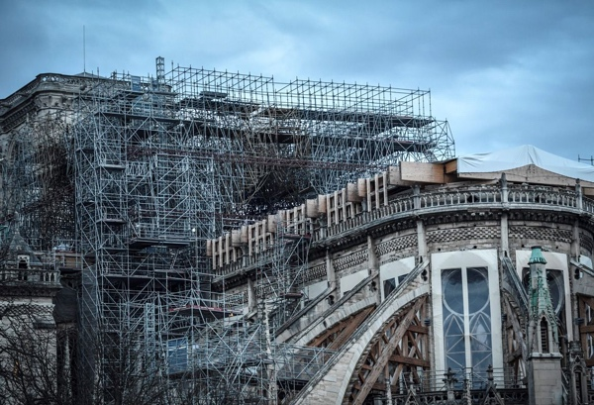

[Paris, Notre Dame Cathedral, 12/2019]



**Course Description:** This seminar will explore the mutability of art objects and sites during their lives, through changes in initial plans, and through remixing and revising, reusing and restoring during the decades or centuries of their subsequent lives. What makes a thing complete, and what is an authentic, original state?

Questions can explore facture and function, fragmenting, remodeling or updating, restoring, collecting, and the role that incomplete or revised states play in the status of art objects evoked or treasured in later centuries.



**Course Requirements**: Grading for this course will be based on the following:

Participation and discussion 20%

Four presentations, each @10% 40%

Main Research Presentation 15%

Research Paper 25%

Readings will be drawn from books, book chapters, and articles electronically available or at the Reserve Desk in Ellis Library.



**Contact Information:**

[StantonA@missouri.edu](mailto:StantonA@missouri.edu)

Swallow 208

Office hours Wednesdays 1-3 and by appointment

Mailbox in Swallow 102



**Departmental and University Policies:**

**Academic Integrity**. Academic integrity is fundamental to the activities and principles of a university. All members of the academic community must be confident that each person's work has been responsibly and honorably acquired, developed, and presented. Any effort to gain an advantage not given to all students is dishonest whether or not the effort is successful. The academic community regards breaches of the academic integrity rules as extremely serious matters. Sanctions for such a breach may include academic sanctions from the instructor, including failing the course for any violation, to disciplinary sanctions ranging from probation to expulsion.

* **Plagiarism** is the submission of another person's work or thoughts as one's own, either by direct copying or by insufficient acknowledgement of the source. This includes copying or downloading material from the Internet, or incorporating a friend’s idea without acknowledgement. If you have any doubts about how to use material properly in a research environment, please talk with me before you turn in your paper.

**Attendance**. Since discussion and presentation is a critical part of the grade, **regular and** **participatory** attendance is vital to the success of each student. Please contact me in the event of any necessary absences (for illness, family emergency, or professional travel). Substantial absences – whether in body or in spirit – will have a negative effect on your course grade.

**Students with Disabilities.** If you need accommodations because of a disability, if you have emergency medical information to share with me, or if you need special arrangements in case the building must be evacuated, please inform me immediately. Please see me privately after class, or at my office. To request academic accommodations (for example, a notetaker), students must also register with the Office of Disability Services (<http://disabilityservices.missouri.edu>), S5 Memorial Union, 882-4696. It is the campus office responsible for reviewing documentation provided by students requesting academic accommodations, and for accommodations planning in cooperation with students and instructors, as needed and consistent with course requirements. For other MU resources for students with disabilities, click on "Disability Resources" on the MU homepage.

**Statement on Intellectual Diversity.** The University community welcomes intellectual diversity and respects student rights.  Students who have questions or concerns regarding the atmosphere in this class (including respect for diverse opinions) may contact the Departmental Chair or Divisional Director; the Director of the Office of Students Rights and Responsibilities (<http://osrr.missouri.edu/> ) or the MU Equity Office (equity@missouri.edu; <http://equity.missouri.edu/> )  All students will have the opportunity to submit an anonymous evaluation of the instructor(s) at the end of the course.

**Semester Schedule: Overview**

(Subject to Change)



**01/27:** Introductions and overview of seminar questions

**02/03:** Making: Workshop practices and the role of the maker

**02/10:** Tour of Special Collections (Meet in Ellis Library, 4th floor west)

**02/17:** Making: Modular construction of manuscripts

**02/19**: Kate Rudy Lecture

**02/24:** Remaking: Updating manuscripts

**03/02:** Remaking: Remodeling churches

**03/09:** Restoring and rebuilding: What is authentic?

**03/16:** Interim research reports

**03/24:** **SPRING BREAK!**

**03/30:** Collecting: A different kind of completion

**04/06:** Working with fragments: Context or completion

**04/13:** Evoking authenticity: homage, copy, or fake

**04/20:** Presentations

**04/27:** Presentations

**05/04:** Presentations

**05/12:** Papers due