**ARHA 4120 / 7120**

**GENDER AND THE ARTS**

**Instructor: Professor Michael Yonan (yonanm@missouri.edu)**

**Fall 2018, T/Th 12:30 – 1:45, 110 Swallow Hall**

**Office Hours: by appointment**

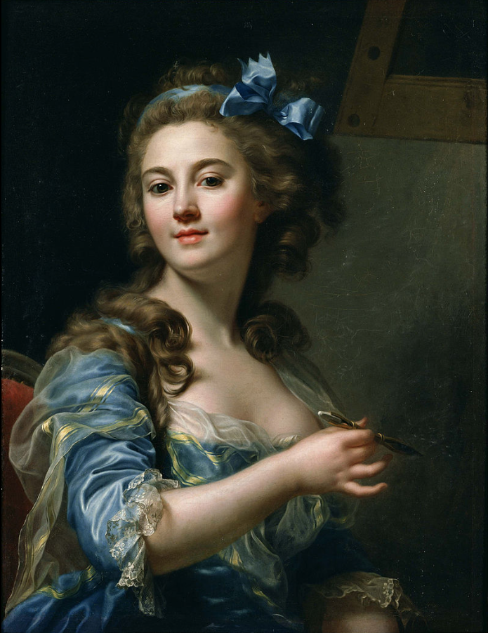

**COURSE DESCRIPTION AND OUTCOMES:**

This course analyzes ways in which gender and sexuality affect our understanding of the arts. The course is divided into four sections. The first, “Women Artists,” focuses on the most central question in the field, namely the place of women artists in the scholarly understanding of art history. The second, “Gender and Visual Theory,” concerns how vision and gender have been theorized by influential cultural critics. The third section, “Gayness, Queerness, and Art” looks at the queering of art and its history, that is, how the exploration of non-heteronormative sexualities and identities affect how we look at art. Finally, “Gender and Material Culture” examines how thinking about gender might help us understand objects, as opposed to images. The course will be run as a seminar and each student will pursue a semester-long project resulting in a research paper appropriate to their level.

Marie-Gabrielle Capet, *Self-Portrait*, ca. 1783 (Tokyo: National Museum of Western Art)

**REQUIRED TEXTS:**

Whitney Chadwick, *Women, Art, and Society*. 5th edition (Thames & Hudson, 2012)

Hannah Greig, et al, eds. *Gender and Material Culture in Britain since 1600* (Palgrave, 2016)

Amelia Jones, ed. *The Feminism and Visual Culture Reader* (Routledge, 2010)

Christopher Reed, *Art and Homosexuality* (Oxford, 2011)

Plus a series of PDFs I’ll distribute to the class as needed.

**COURSE REQUIREMENTS:**

Attendance and Participation: 25%

Abstract and Bibliography: 5%

Detailed outline: 10%

Presentation: 20%

Research Paper: 40%

**RESEARCH PROJECT:**

This is the major activity of the semester and consists of several components. You will select a topic related to the course theme, research it extensively, present your findings to your colleagues in class, and write a polished final paper on the subject.

**Selecting a topic:** I’ll suggest viable subjects as the semester gets going, but a good way to find a topic is through basic Internet searches and searching through ARTSTOR ([www.artstor.org](http://www.artstor.org)). It is important that the course’s participants write on a range of things, so I may encourage some of you to work on certain topics.

**Abstract and Bibliography:** You will submit a typed description of your research topic (3­–4 sentences) as well as a short preliminary bibliography of at least five sources beyond the course readings. These must consist of scholarly books and articles and may not include survey texts or blogs.

**Detailed Outline:** You are required to produce a detailed outline of your paper for a grade. This should be a minimum of one page in length and can be considerably longer depending on the progress of your work. I do this to prevent procrastination and indecision, habits that make for poor scholarship. You should in your outline state a clear, forthright thesis. E. g. “Gender is an important theme in the paintings of Suzanne Valadon.” Or “French revolutionary painting was oriented around issues of masculinity.” Your subsequent points must answer, test, disprove, or otherwise examine your thesis, but all must engage with it. Long strings of factual information don’t make a successful paper; nor does stream-of-consciousness prose. The purpose of this assignment is to force you to structure your ideas so that you can develop them properly.

This is a research paper requiring trips to the library/library website to investigate published sources about your work of art. Internet sources might be useful as a start, but a paper that relies too heavily or exclusively on unscholarly websites will receive a grade of C or lower. **Go to the library website and use its resources:** <http://library.missouri.edu>.

**Presentation:** Each student will share their research with the class in a presentation on his/her paper topic. You must use an appropriate visual aid in your presentation, typically Power Point. You will be graded on three things: your general preparedness, the quality of your abstract and bibliography, and the content and delivery of your presentation. Undergrads (4120) will speak for 10 minutes; grads (7120) for 20 minutes.

**Research Paper:** Your final paper shall bring together your thinking into a well-researched, well-argued, and polished final form. It should argue a specific point from a unique perspective while also engaging with larger questions we have discussed during the semester. My advice, as always, is to select a theme that you find personally interesting, since doing so will result in a better experience for you and a finer end product overall.

You must properly cite all sources you consult as you write your paper. Ellis Library has a terrific web guide to citation available at

<http://libraryguides.missouri.edu/citationguide>

They also have a page of tools, tips, and software/apps available for use at the above site.

All written work should be computer-printed on 8.5 x 11-inch paper and double-spaced. Use margins no larger than 1.25 inches. Use a commonplace, easily readable font (Times New Roman, Arial, etc.) in 12 point. Include page numbers. Include printouts or photocopies of all works of art you discuss in your paper. Please clip your paper together in the upper-left corner; do not bind your essay in a folder. Emailed papers will not be accepted; please print out your paper and present it to me in person.

No extra credit will be offered in this course.

**SPECIAL REQUIREMENTS:**

**Undergrads** taking the course should select a single work of art to discuss in their semester projects. The in-class presentation is an exploration and demonstration of your research on the work, 10 minutes in length. The final paper is a write-up of your findings totaling 10–12 pages. MLA style (internal citation) is acceptable, or whatever citation system is most comfortable for you.

**Grads** should write a paper of minimum 17 pages in length and preferably around 20. Graduate students are expected to research their subjects thoroughly, fully addressing the scholarly literature on their material, and are expected to examine sources in multiple languages when appropriate. Graduate students are also required to use Chicago style with endnotes. In general, your contributions to the course will be assessed as if they were the parallel professional scholarly activity. The paper proposal is analogous to a proposal for a conference paper; the in-class presentation analogous to reading a paper at an academic conference; and the final paper analogous to an article you might submit to a journal for peer review and publication.

**MFAs** will choose an artist, living or deceased, whose work in some respect compliments the work you do in your studio practice. Your paper will be an exploration of their work and the ways in which it relates to the themes of gender, femininity, sexuality, queerness, etc., that we discuss this semester. I would rather you did not write about your own art, but instead use the course to find inspiration and to contextualize your artistic work meaningfully.

**A NOTE ON PROCEDURE:**

I treat this course as a seminar. There will be no lectures, but rather regular discussions. Your individual take on the readings is extremely valuable to our collective learning. Speak your mind and please don’t say what you think the professor wants to hear. Feel free to guess, speculate, imagine, ponder out loud, or otherwise question the issues at hand. That’s what a seminar is for. That said, in a course on gender, we will each have different perspectives on the subjects at hand and will speak from positions rooted in different experiences. It is imperative that you remain respectful of others’ positions, identities, and beliefs.

**ATTENDANCE AND PARTICIPATION:**

Attendance is mandatory. This is not a distance-learning course. You are expected to be present and prepared on the days we meet. Having a busy life does not excuse your absences. Unless a written statement can be provided by a university authority (e. g. the dean), all absences are unexcused. More than three unexcused absences will result in a lowered grade; more than six will result in a course grade of F. Repeated late arrivals will be treated as absences.

In addition to regular attendance, this course demands a certain amount of work outside of the classroom, mostly reading. You are expected to have knowledge of the assigned readings’ content and to recognize the major works of art we discuss. It’s more important to grasp the major concepts and themes of the readings than to remember minute details, so read to discern the big picture. As with the readings, all course assignments must be completed by the dates indicated. Late assignments will receive reduced grades at the value of half a letter grade for every day late.

Participation consists of attending class regularly, contributing to class discussions, and completing assignments on time. Failure to participate will harm your grade irrevocably. I also ask that you maintain a common level of courtesy and respect toward your fellow students by silencing your cell phones and other electronic devices, not engaging in disruptive activities in class and remaining focused on the discussion at hand. Failure to be courteous to others will likewise negatively affect your participation grade.

If you cannot commit the required time, attention, and participation to this course, it’s best to drop it.

**POLICIES:**

**Academic Integrity**: In accordance with the University of Missouri Academic Integrity Policy, students are asked to review the university’s policies against plagiarism and cheating, which are available in multiple places on the MU website, including:

<http://osrr.missouri.edu/academicintegrity/index.html>

Academic integrity is fundamental to the activities and principles of a university. All members of the academic community must be confident that each person's work has been responsibly and honorably acquired, developed, and presented. Any effort to gain an advantage not given to all students is dishonest whether or not the effort is successful. The academic community regards breaches of the academic integrity rules as extremely serious matters. Sanctions for such a breach may include academic sanctions from the instructor, including failing the course for any violation, to disciplinary sanctions ranging from probation to expulsion. When in doubt about plagiarism, paraphrasing, quoting, collaboration, or any other form of cheating, consult the course instructor.

**Students with Disabilities**: If you have a special need as defined by the Americans with Disabilities Act (ADA) and require accommodations to take this this course, please notify the instructor and the Office of Disability Service, S5 Memorial Union, 882­–4696. Their web address is: <http://disabilityservices.missouri.edu/>. Reasonable efforts will be made to accommodate your special needs.

**GRADING SCALE:**

A+ 98­–100

A 93–97

A- 90–92

B+ 88–89

B 83–87

B- 80–82

C+ 78–79

C 73–77

C- 70–72

D+ 68–69

D 65–67

F 64 and below

**SCHEDULE**

Aug 21 Introduction and Administration

**UNIT ONE: WOMEN ARTISTS**

Aug 23 Chadwick, Preface and Introduction; Jones, ch. 29 (Nochlin)

-

Aug 28 Chadwick, Chapters 3 and 5

Aug 30 Chadwick, Chapters 8 and 9

-

Sep 4 Chadwick, Chapters 10 and 11

Sep 6 Chadwick, Chapters 12 and 14

-

**UNIT TWO: GENDER AND VISUAL THEORY**

Sep 11 Jones, Ch. 9 (Mulvey), ch. 11 (Doane)

Sep 13 Jones, Ch. 16 (Grosz), ch. 15 (Phelan)

-

Sep 18 Jones, Ch. 14 (hooks), ch. 31 (Piper)

Sep 20 Jones, Ch. 54 (Butler), ch. 57 (Nead)

-

Sep 25 Jones, Ch. 18 (Halberstam), ch. 27 (Muñoz)

**UNIT THREE: GAYNESS, QUEERNESS, AND ART**

Sep 27 Reed, Ch. 1, Varieties of ‘Homosexuality’, Varieties of ‘Art’

-

Oct 2 **No class–Copenhagen**

Oct 4 Reed, Ch. 2, “Before Modernism”

-

Oct 9 Reed, Ch. 4, Secrets and Subcultures, 1900–1940

Oct 11 Reed, Ch. 6, Avant-Garde and Activism, 1965–82

-

Oct 16 Reed, Ch. 8, Queer and Beyond

**UNIT FOUR: GENDER AND MATERIAL CULTURE**

Oct 18 Greig, et al, Intro: Gender and Material Culture

-

Oct 23 Greig, Chs 2 (Hannan) and 4 (Harvey)

Oct 25 Greig, Chs 3 (Vincent) and 6 (Clark)

-

Oct 30 Mary D. Sheriff, “Seeing Beyond the Norm: Interpreting Gender in the Visual Arts,” in *The Question of Gender* (2011) (PDF)

Nov 1 **No class–HECAA conference**

-

Nov 6 Presentations

Nov 8 Presentations

-

Nov 13 **No class–Evansville**

Nov 15 Presentations

-

Nov 20 & 22 **No class–Thanksgiving break**

-

Nov 27 Presentations

Nov 29 Presentations

-

Dec 4 Presentations

Dec 6 Presentations

**Semester paper due on 11 December 2018, by noon.**