the contract  Grading for this class is simple: pick the grade you plan to earn and look at the list below. If you can check off all those items at the end of the semester, you get that grade.  I WANT AN A  -Don’t miss more than three classes. (No excused absences.)  -Meet with Scott at least twice during the semester in his office hours.  -Turn in all five Instagrammar assignments on time.  -Turn in three drafts of the major essays: a workshop draft, a revised draft, and a final version.  -Turn in an Unprintable Essay.  -Perform a piece in the Story Slam.  -Lead two class discussions.  -Turn in a one-page review of every other student’s workshop essays.  -Be a good citizen of the class.  I WANT A B  -Don’t miss more than five classes. (No excused absences.)  -Meet with Scott at least once during the semester in his office hours.  -Turn in four Instagrammar assignments on time.  -Turn in two drafts of the major essays: workshop draft and a revised draft. Then produce a final revised draft of one of the two essays.  -Perform a piece in the Story Slam.  -Lead one class discussion.  -Turn in a one-page review of every other student’s workshop essays. You get two freebies.  -Be a good citizen of the class.  I WANT A C  -Don’t miss more than seven classes. (No excused absences.)  -Meet with Scott at least once during the semester in his office hours.  -Turn in three Instagrammar assignments on time.  -Turn in two drafts of the major essays: workshop draft and revision.  -Lead one class discussion.  -Turn in a one-page review of every other student’s workshop essays. You get four freebies.  -Be a good citizen of the class.  SIGN AND DATE HERE: |  |  | English 2520:  Intermediate Creative Nonfiction  Figure 1: From Nox, Anne Carson  Instructor: eric O. scott  The class meets in Middlebush 206 MWF 1:00 – 1:50 PM.  You can visit Scott in Tate Hall 004 MWF 11:00 AM – 12:30 PM.  Scott’s email address is eosbn4@mail.missouri.edu

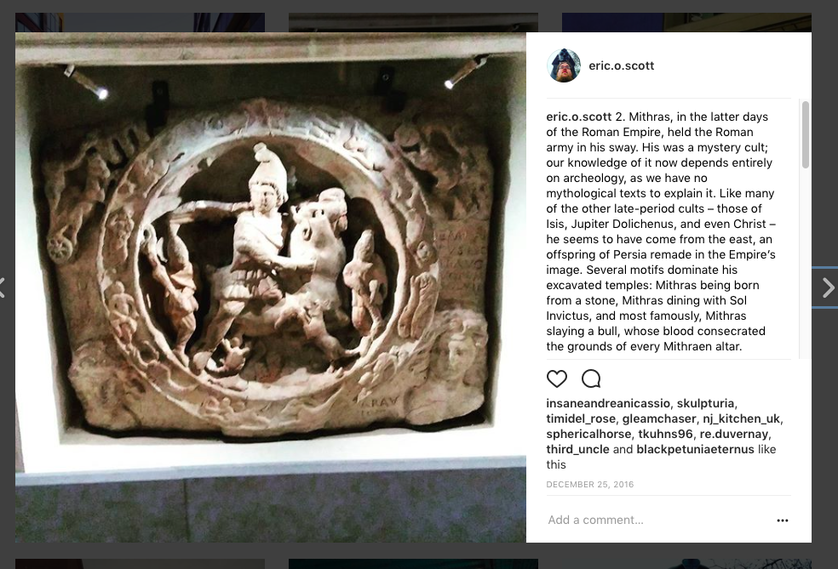  Figure 2: One of your humble instructor's own Instagram essays. |  |  | university notices  Diversity & Disability  This class is meant to be a safe space for all students. I will make every effort to respect each student's preferred name, pronouns, and gender identity. If another student's words or actions make you feel threatened or diminished, please let me know.  ADA Statement  If you need accommodations because of a disability, if you have emergency medical information to share with me, or if you need special arrangements in case the building must be evacuated, please inform me immediately. To request academic accommodations (for example, a note-taker), students must also register with the Office of Disability Services, (http://disabilityservices.missouri.edu), S5 Memorial Union, 882-4696. It is the campus office responsible for reviewing documentation provided by students requesting academic accommodations, and for accommodations planning in cooperation with students and instructors, as needed and consistent with course requirements. For other MU resources for students with disabilities, click on “Disability Resources” on the MU homepage.  University of Missouri Notice of Nondiscrimination  The University of Missouri System is an Equal Opportunity/ Affirmative Action institution and is nondiscriminatory relative to race, religion, color, national origin, sex, sexual orientation, age, disability or status as a Vietnam-era veteran. Any person having inquiries concerning the University of Missouri-Columbia's compliance with implementing Title VI of the Civil Rights Act of 1964, Title IX of the Education Amendments of 1972, Section 504 of the Rehabilitation Act of 1973, the Americans With Disabilities Act of 1990, or other civil rights laws should contact the Assistant Vice Chancellor, Human Resource Services, University of Missouri-Columbia, 130 Heinkel Building, Columbia, Mo. 65211, (573) 882-4256, or the Assistant Secretary for Civil Rights, U.S. Department of Education.
 |  |  | 5

coursework & grades  Required Texts:  Citizen 13660 by Miné Okubo (ISBN 978-0295993546)  Nox by Anne Carson (ISBN 978-0811218702)  Wisconsin Death Trip by Michael Lesy (ISBN 978-0826321930)  The Book of Embraces by Eduardo Galeano (ISBN 0393308553)  Plus lots of online stuff.  Turning Things in  Turn in all work via Canvas. For workshop essays: post them as discussion threads. For workshop responses: post them as responses in the discussions. For Instagrammar: submit the URL of your Instagram post to the assignment. Submit traditional essays as Word documents. Talk to me about nontraditional essays before you submit them. For the love of Truman the Tiger, please save all your work.  Plagiarism, Cheating, and Falsehoods  Creative nonfiction, more than any other genre, depends on trust between the author and the reader. If a nonfiction writer breaks faith with the reader, that writer can no longer be trusted. Follow journalistic ethics. If you have a question about how to write ethically, please speak with me. Plagiarism or fabrications will be treated as an immediate breach of contract and may be grounds for expulsion from the course.  Class Readings and Discussion  Finish the readings before the day they’re listed on the calendar. Everybody leads class discussion at least once. On your day, you’re in charge – you’re responsible for identifying key themes in the text to concentrate on, and you’re responsible for starting and guiding the conversation. Make sure you bring at least two questions of craft – think about what we can learn from the text as writers.  Assignments  You’ll get full assignment sheets, but in short: five flash Instagram essays (400 words each), two workshop essays (minimum 10 double spaced pages or the equivalent), 28 one-page workshop responses. |  |  | This class visits the place where design meets the essay.  We’re here to read creative nonfiction that blends text with the image – photographs, line drawings, flash animations, scrapbooks, you name it – and to consider how we might take our work beyond the standard 12 point Times New Roman one-inch margins manuscript format.  We’re also here to write to an audience – we’ll be publishing flash essays to social media and performing pieces for live audiences. All of this plus the detailed feedback of the workshop that you expected. We have a lot to do here, but I hope you’ll find this an unexpected and rewarding challenge.
4 |  |  | 1

course calendar  This is all on Canvas, too. If the title doesn’t match one of your books, assume it’s on the web – your Canvas calendar has the links.  8/23 – Intro, Eclipse Interviews  8/25 - What We Saw After the Attacks on Paris  8/28 – The Last Days of High Bridge Arms  8/30 – my body - a Wunderkammer  9/1 – Fitting the Pattern; Instragrammar 1 (Review/Criticism)  9/4 - LABOR DAY, NO CLASS  9/6 - Mr. Plimpton’s Revenge  9/8 - Blue Velvet  9/11 - Citizen 13660; Workshop essays due  9/13 - Citizen 13660  9/15 - Workshop 1; Instagrammar 2 (Profile/Interview)  9/18 - Workshops 2/3  9/20 - Workshops 4/5  9/22 - Workshops 6/7  9/25 - Workshops 8/9  9/27 - Workshops 10/11  9/29 - Workshops 12/13  10/2 - Workshops 14/15  10/4 - Nox  10/6 – Nox; Instagrammar 3 (Lyric) |  |  | cc, con’t  10/9 - Wisconsin Death Trip  10/11 - Wisconsin Death Trip  10/13 - Special Collections Visit; Essay revisions due  10/16 - The Book of Embraces 1-99  10/18 - The Book of Embraces 99-199  10/20 - The Book of Embraces to end; Instagrammar 4 (Travel/Place)  10/23 – The Moth: Modern Family  10/25 – 99% Invisible: Heyoon  10/27 – Snap Judgment: The Curse; Workshop essays due  10/30 – TBD!  11/1 - Workshop 1  11/3 - Workshops 2/3  11/6 - Workshops 4/5  11/8 - Workshops 6/7  11/10 - Workshops 8/9  11/13 - Workshops 10/11  11/15 - Workshops 12/13  11/17 - Workshops 14/15  11/20 – 11/25 – THANKSGIVING BREAK, NO CLASS  11/27 – 12/1 – TBD: Field Trip, Requested Topics  12/4 - 88 Constellations for Wittgenstein  12/6 - Telemetry; Instagrammar 5 (Memoir)  12/8 - READING DAY  12/12 - FINAL PORTFOLIO DUE BY NOON
2 |  |  | 3

