**Ex Libris**

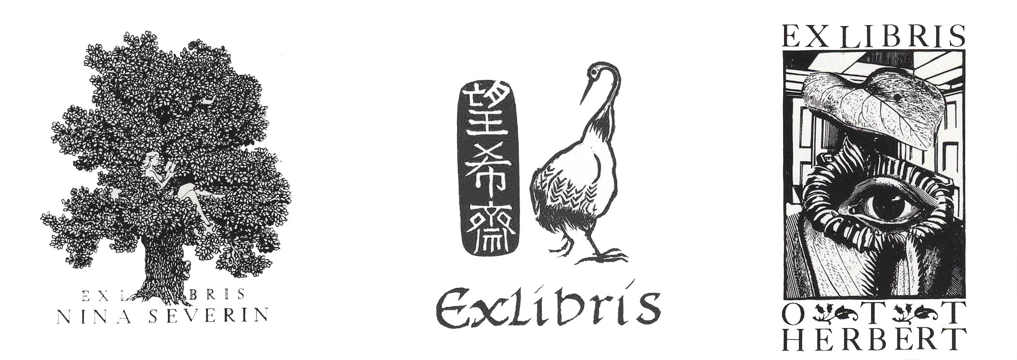

For this assignment, you will create an illustration for a bookplate. A bookplate is a label pasted inside a book and bearing the owner’s name. In this case, you are the owner and the bookplate should reflect something about yourself.

Often, the Latin words, Ex Libris, (in the library of) are incorporated into the design of a bookplate. Use this typographical element in the development of your sketch and include it in your final art.

Reproduction size: about the size of a playing card. Your work may be in the shape of a square, circle, rectangle, etc. Execution of the final art should be in black ink or scratchboard with no halftone and no smaller than 8” in any direction.

Final art should be presented in 2 formats:

1. Mount original art on heavy weight, white cardstock or mat board. Leave a 1 or 2 inch border around the art. Provide a flap for the art for protection.
2. Mount a copy, (Xerox or laser print) of your bookplate onto a decorative paper (the type that might be found on the endpapers of a book).