Using a monitor in a student group study room (8/3/2021)
Available in Rooms 151E, 151F, 151G, 2E21, 3G61, 3G62, 4B12
The monitor allows a student to share their laptop screen, so all in the room can see it.
First-Time Users for Windows
To use the monitor, follow the steps on the screen:
- Make sure that the laptop is connected to TigerWifi, as noted in step 1 in the photo.
- In a web browser, go to the http:// (URL) on the monitor (in the photo below, http://128.206.160.79).
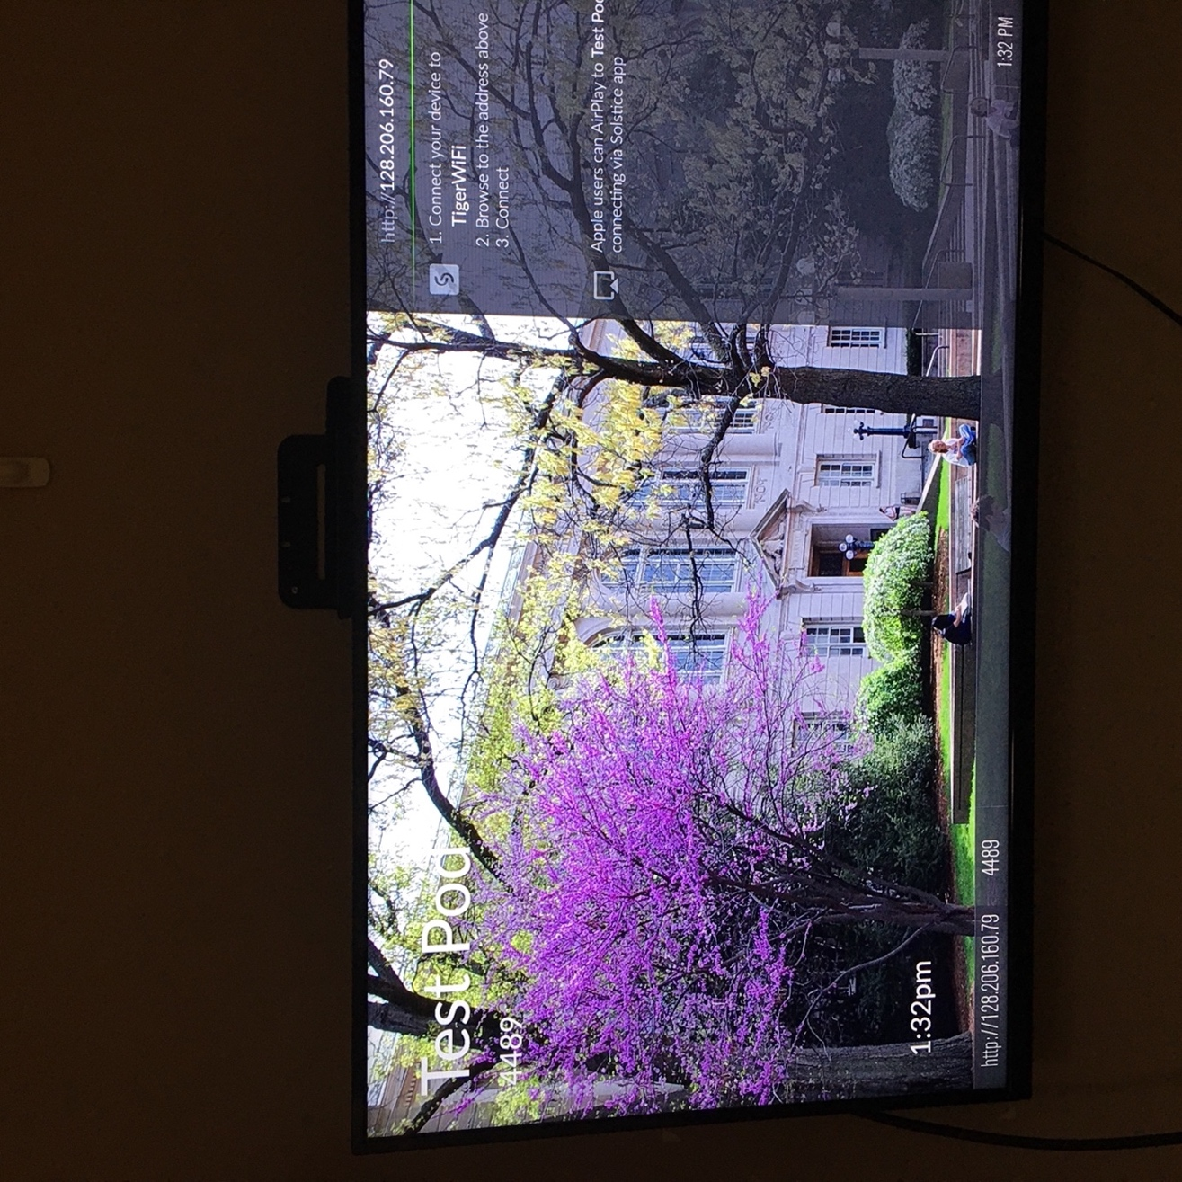

You will be prompted to download the Solstice App (the app connects the laptop to the monitor).
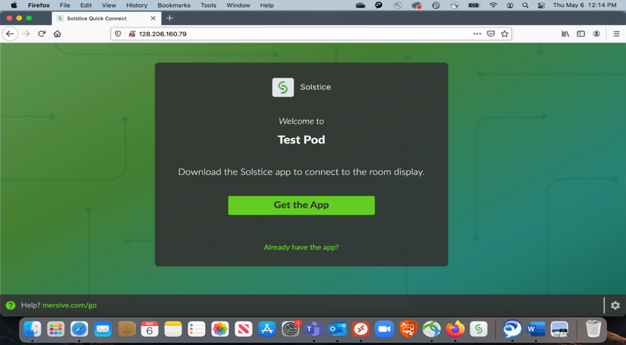
- Open the app and type the URL into the “Quick Connect” box
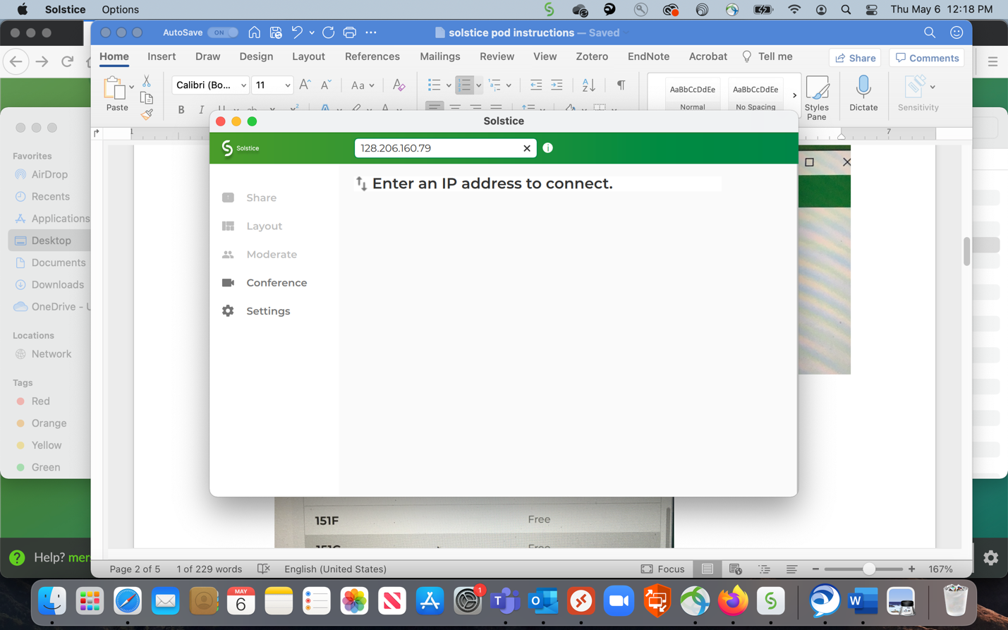

OR choose the name of the room if it displays. In this example, click on “Test Pod”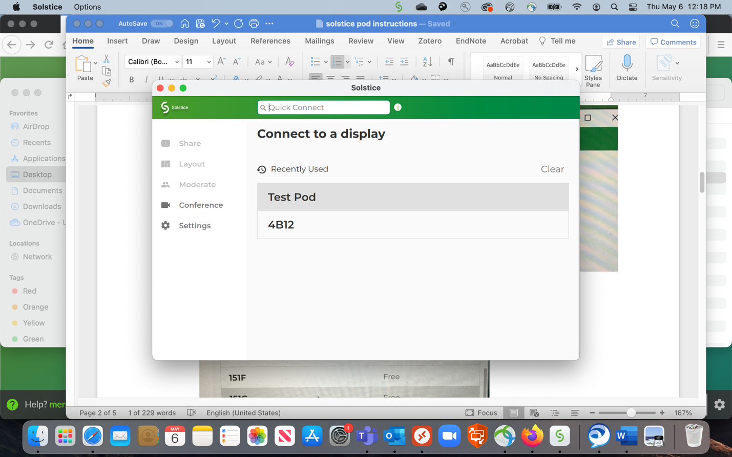

- The study room monitor will display a screen key (example: “4500” below).
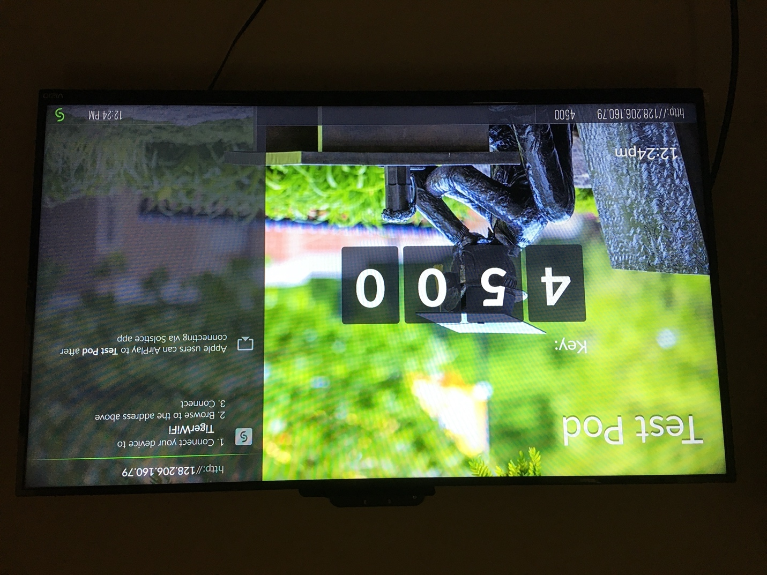
5. On your laptop, enter the screen key when prompted.
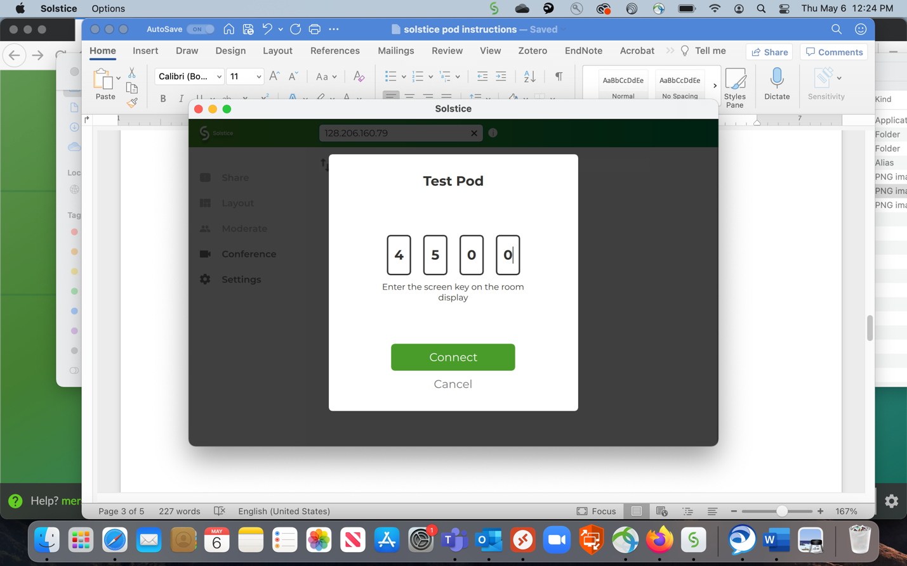
The laptop is now connected to the monitor and is ready to share content.
choose to share the Desktop, App Window (just one application) or a Media File. Your content will be displayed on the monitor.
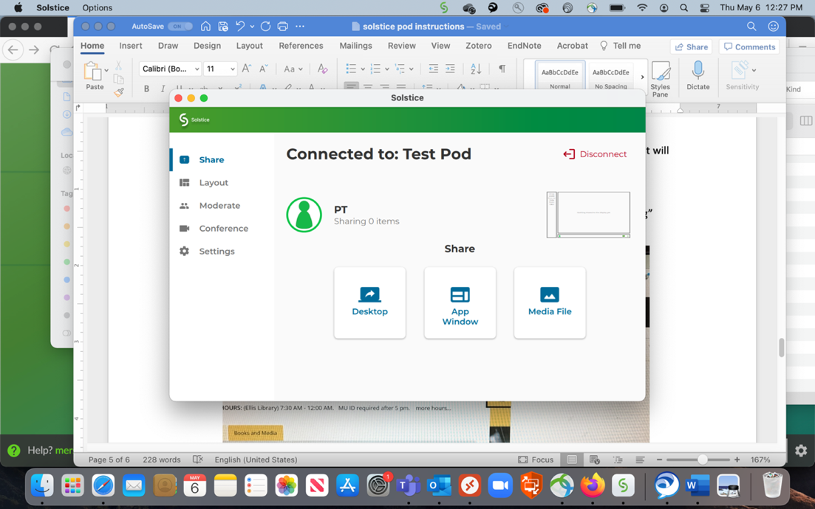
Example of a connected desktop below.
To stop sharing, click the “Stop Sharing” button at the top of the laptop screen.

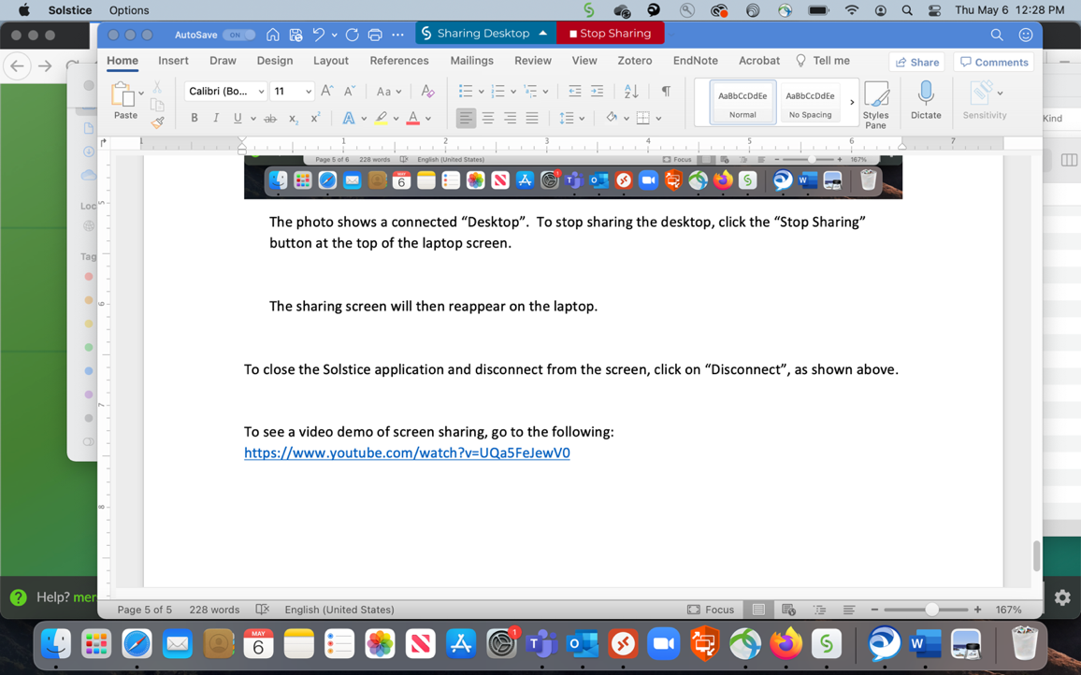
The sharing screen menu will then reappear on the laptop.

To close the Solstice application and disconnect from the screen, click on “Disconnect.”
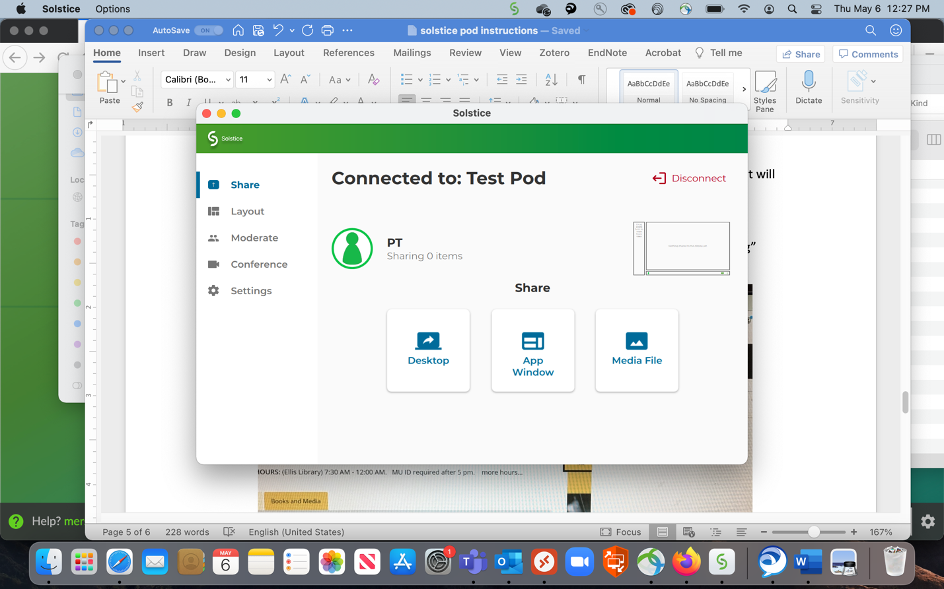

To see a video demo of screen sharing, go to: https://www.youtube.com/watch?v=UQa5FeJewV0

First Time Users - Mac
To use the monitor, follow the steps on the screen:
- Make sure that the laptop is connected to TigerWifi, as noted in step 1 in the photo.
- In a web browser, go to the http:// (URL) on the monitor (in the photo below, http://128.206.160.79).

You will be prompted to download the Solstice App (the app connects the laptop to the monitor).

- From the Downloads folder, open the app and type the URL into the “Quick Connect” box

OR choose the name of the room if it displays. In this example, click on “Test Pod”

- The study room monitor will display a screen key (example: “4500” below).
5. On your laptop, enter the screen key when prompted.
The laptop is now connected to the monitor.
First-time Mac/Apple Users must enable screen recording in System Preferences to share content.
When you receive the screen below, re-enter the URL (http:// ) address in the Quick Connect area.
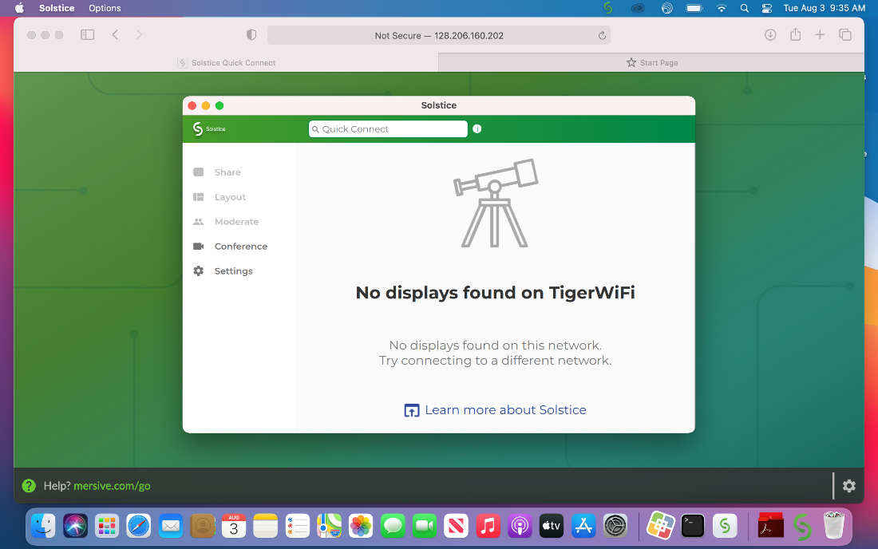

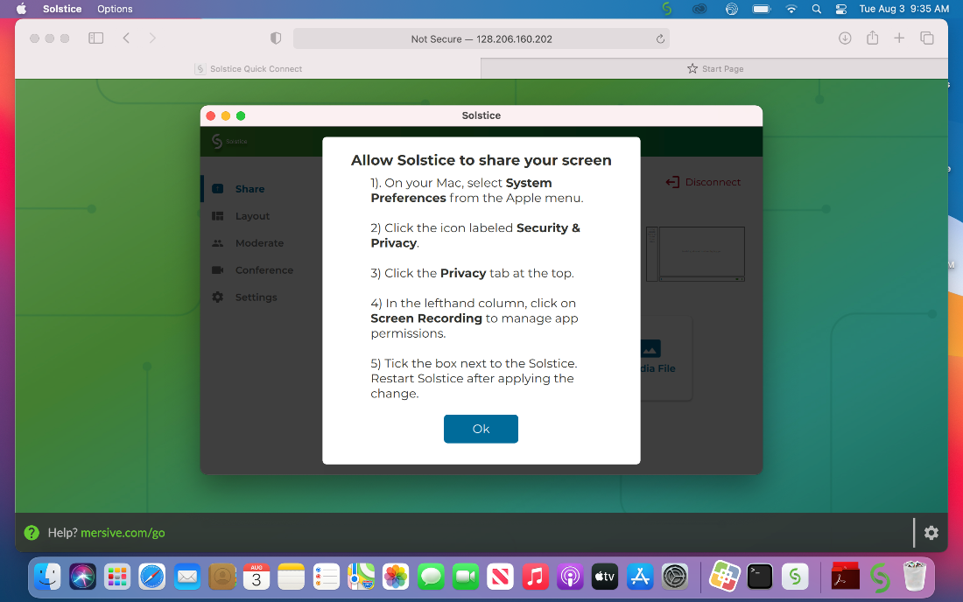
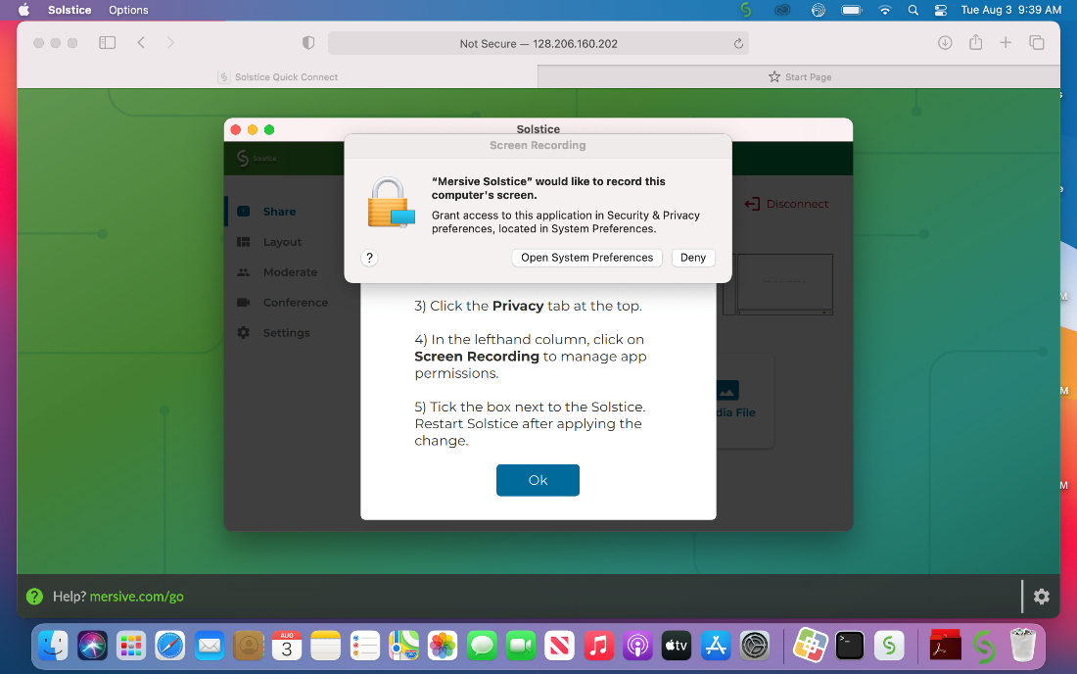
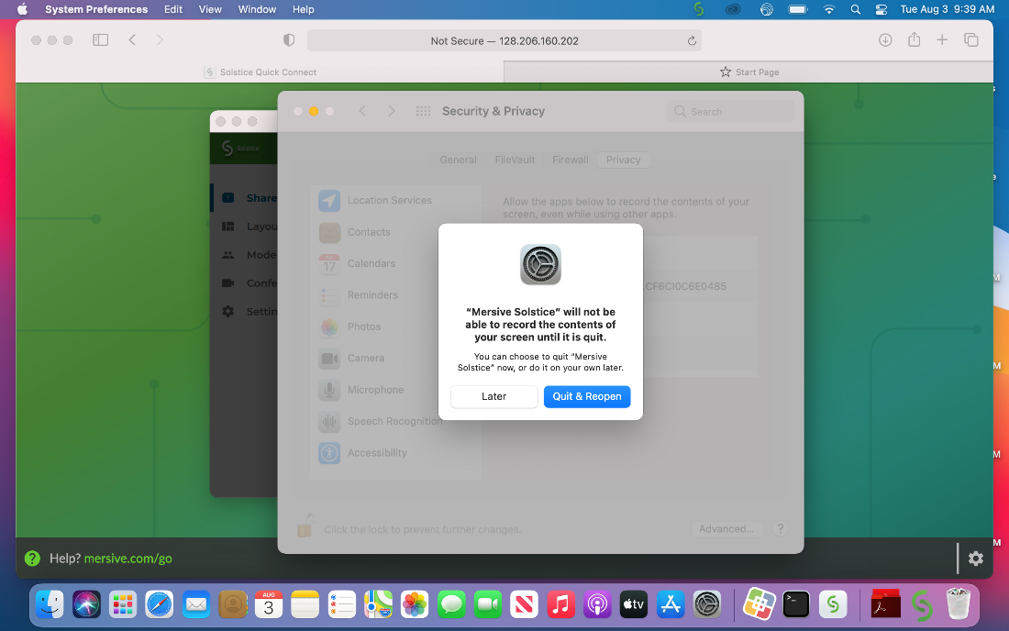
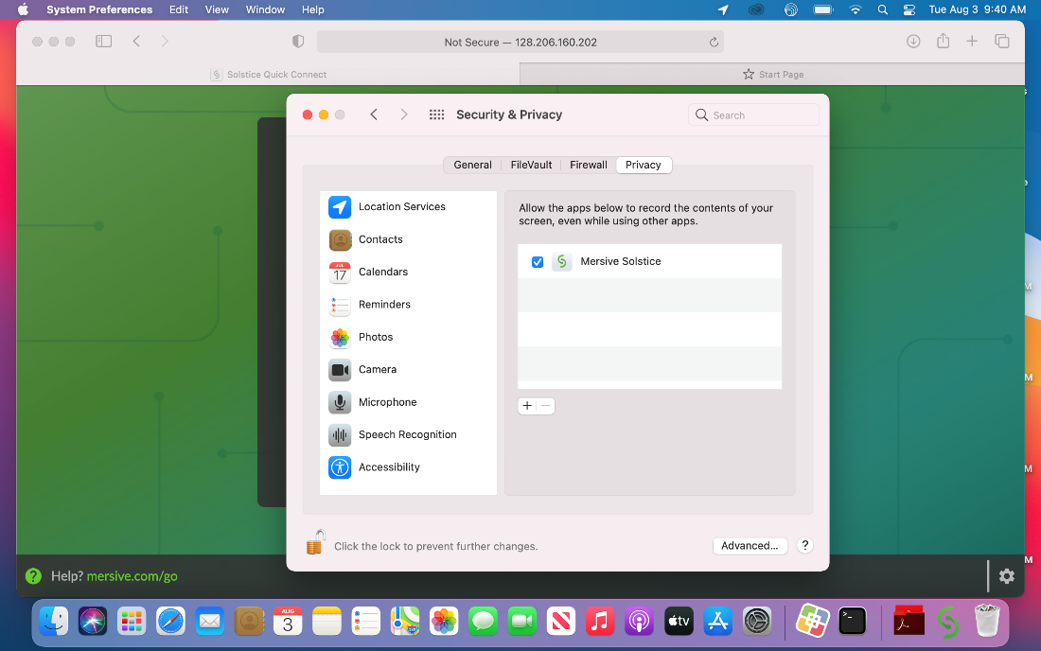
Once screen recording is enabled, reopen the Mersive Solstice app.
You may choose to share the Desktop, App Window (just one application) or a Media File. Your content will be displayed on the monitor.
Example of a connected desktop below.
To stop sharing, click the “Stop Sharing” button at the top of the laptop screen.

The sharing screen menu will then reappear on the laptop.

To close the Solstice application and disconnect from the screen, click on “Disconnect.”

To see a video demo of screen sharing, go to: https://www.youtube.com/watch?v=UQa5FeJewV0

Mac/Apple Instructions using AirPlay:
Follow steps 1-5 above.
Once connected, DO NOT connect with the “Desktop” button, select the AirPlay icon at the top of the screen and select the room number (example: “Test Pod”).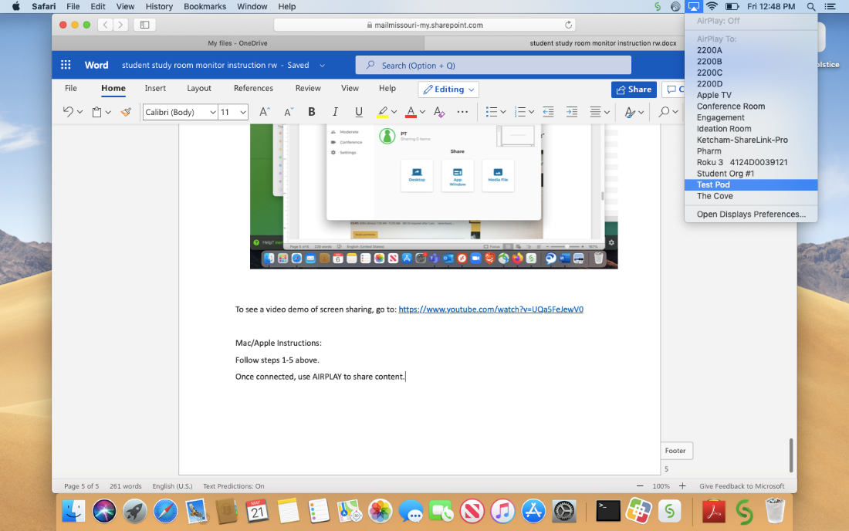

Enter the 4 -digit code that appears on the monitor.
.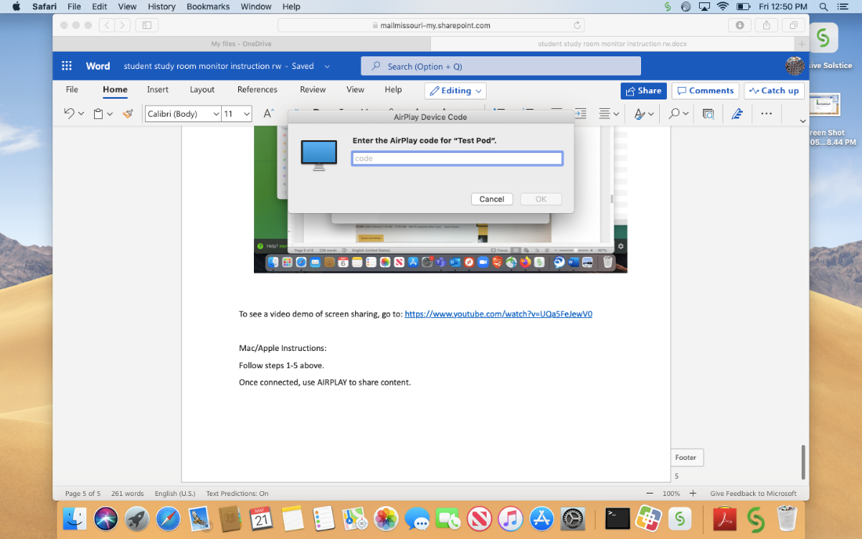
Your desktop will now display on the monitor.
Turn AirPlay off to stop sharing.

Returning users: Open Solstice App and select room or enter IP address in the Connect box.

