**Library Assembly January 2015 (January 27, 2015 Meeting cancelled)**

Departmental Announcements; in lieu of the regular January 2015 meeting

These minutes are also available at: <http://library.missouri.edu/staff/committees/libraryassembly/>

Director’s Announcements: Jim Cogswell

* Link to All-Staff Meeting Notes and Presentation – <http://libraryguides.missouri.edu/c.php?g=28456&p=174852>
  + Look for this link in upcoming editions of Library News Notes also.

Jack Batterson, Cataloging and Metadata:

* Alan Jones's retirement party was on January 22, 2015 at 12:30 pm, and Jerri Eldridge's retirement party will be on Friday, Feb. 6, 2015 from 1 pm-2:30 pm in Cataloging & Metadata.
* Planning is underway for the transfer of 16,000 volumes from ENGR to U1
* The RDA remastering project that has been updating the catalog records to include RDA fields is expected to be completed by Feb. 13, 2015.

Mold project- Catalog management:

* We are still working on replacement and discards of Y 4 government documents.
* As materials are reprocessed into UMLD2, the status will become "available" in MERLIN. We are running Merlin lists three times per day.
* We are also in the process of suppressing "disposed" items from the MERLIN catalog. This is temporary prior to discards and this will help patrons.
* We are cataloging Y 4 Documents that came as gifts with the Y 4 replacements. These titles are "new to us."

Mat Miller, Digital Services:

* We have two new people in the department: a new Graduate Library Assistant who will be working on institutional repository submissions and cataloging, and a library science practicum student who will also work in Special Collections.  The student will be working on selecting material for digitization, digitizing the material, adding it to our digital library, and writing commentary for each item.  One of our student assistants resigned in December 2014 and we will also be replacing her.
* Journalism Masters Projects through Fall 2014 are now available in the MOspace Institutional Repository.

Shelly McDavid, Veterinary Medical Library:

* We’ve opened up more study space in the library, as well as more natural light. Over Christmas Break 2014, 3 stacks came down!

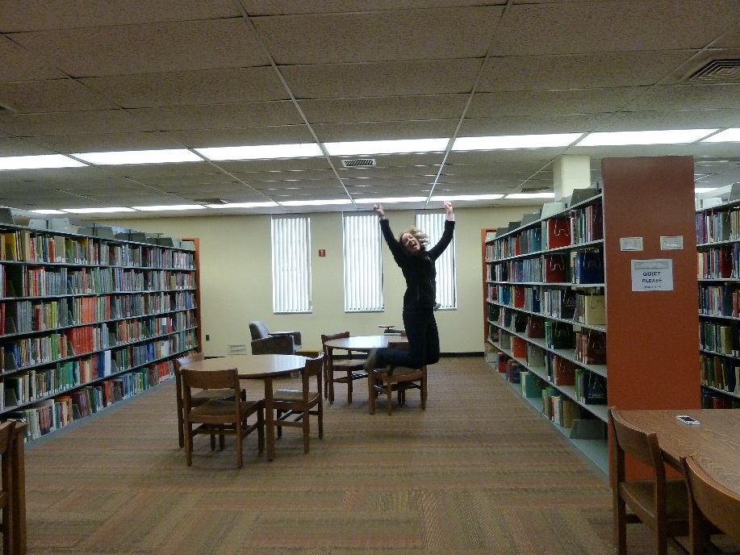

* Gate counts continue to rise. For FY15, we’re up 3,000 patrons over the same time last year; an increase of over 15%.
  + July – December 2014: 20,582
  + July – December 2013: 17,137

Deb Ward, Health Sciences Library:

* We’re still reeling from the news that Darell Schmick is leaving us.
* The reference librarians are involved in the ACT quality improvement project teams made up of clinicians, hospital personnel and students to identify and test ways to improve patient care.
* We’ve discovered that people like coming to workshops over intersession.  Have already had several this year which have been well attended.
* We’re offering a new class this semester on Mendeley reference management software
* Several of our patrons are very excited about our new subscription to Cell Host and Microbe, made possible by a collaboration among several of the science selectors and through cancellation of some low use titles.  Received several comments, including this: “Outstanding.  Metagenomics is the "HOT" new science and this journal is a popular vehicle for publication. Our current NIH grant uses this technology.”
* We recently added charging stations on the 2nd & 3rd floors of the library.
* Amanda discovered an interesting connection between one of the most famous physicians of all time, William Osler, and MU:  <http://library.missouri.edu/hslsuggestions/2015/01/09/william-osler-and-his-connection-to-mu/>
* Deb Ward and Terri Hall are working on a display featuring the conceptual drawings for the renovation of 2nd and 3rd floor.
* New HSL 2nd Floor Art Exhibit by graduate student Kyle Bader, he is exhibiting his paintings of baseball trading cards.
* Mike updated and expanded  the Scopus cited reference search tool, where you can plug in a PubMed ID or an article DOI and get a count and list of cited references.  <http://library.missouri.edu/databases/moreinfo/?id=1963>
* The School of Medicine accreditation review is underway, with a site visit expected in January, 2016. Deb Ward is on one of the review committees, and is responsible for answering the questions that relate to the library.
* Plans for updating the Health Sciences Library facility will be presented at the HSL exit soon. This will be done by displaying a poster about the plans, and by presenting three large renderings of the second floor spaces.  The large renderings include a view of the new service desk and entry area, a view of the proposed coffee shop, and a large-scale lay-out will help users to see the proposed changes realistically. Information Services staff are working on getting the same content up on the HSL web site. There is a comments page set up, with links from the poster, a QR code, and the web page on which the content will be found. We hope to gather some feedback from users regarding the proposed plans while there is still plenty of time for us to make some changes. Thanks to Shannon Cary for getting the large renderings made. Thanks to Mike Spears, Caryn Scoville, and Diane Johnson for the web work, and to Terri Hall for helping me (Deb) create the poster about the Library Redesign Project. Here is a link to view the proposed 2nd floor changes: <http://library.muhealth.org/test/mouse_over_2.html>