PRESERVATION AT THE UNIVERSITY OF MISSOURI--COLUMBIA LIBRARIES
A Report Prepared for the Director of Libraries
August 1, 1986
by
The Preservation Planning Program Study Team
University of Missouri——Columbia Libraries
Deana Astle, Chair
Mary Ailcorn
Carolyn Collings
Margaret Howell
Bill Jackson
This Preservation Planning Program study was supported by the Office of Management Studies of the Association of Research Libraries and funded by the National Endowment for the Humanities

TABLE OF CONTENTS
List of Task Force Members p.2
Executive Summary p.3
Introduction p.6
Physical Condition of the Collections p.9
Environmental Conditions p.13
Processing/Handling/Storage p.17
Disaster Planning p.20
Staff and User Education p.21
Organization for Preservation p.21
Resources for Preservation and Cooperative Ventures p.24
Funding p.27
Implementation p.28
Recommendations p.29
Appendix 1
Temperature/Relative Humidity Graphs of Selected Environments
Appendix 2
Processing/Handling/Storage Detailed Recommendations

LIST OF TASK FORCE MEMBERS
TASK FORCE ON THE PHYSICAL CONDITION OF THE COLLECTION
Bill Jackson, Chair
Karen Eubanks
Tamara Guilford-Davis
Susan Meadows
Mary Ryan
Bob Stevens
TASK FORCE ON ENVIRONMENTAL CONDITIONS
Mary Allcorn, Chair
Deana Astle
Cindy Dailey
Sandra Exner
Linda Lyle
Meridithe Odom
Claudia Powell
TASK FORCE ON PROCESSING/HANDLING/STORAGE
Margaret Howell, Chair
Wayne Barnes
Sharon Kile
Rich Rexroat
Donnell Ruthenberg
Viki Young
TASK FORCE ON ORGANIZATION FOR PRESERVATION, COOPERATIVE VENTURES AND
PRESERVATION RESOURCES
Carolyn Collings, Chair
Jeanne Drewes
Kathleen Edwards
Suzy Frechette
Marsha Stevenson
2
EXECUTIVE SUMMARY
More than 20 percent of the volumes in the UMC Libraries are in such delicate condition that some pages could be reduced to dust through normal use.
This alarming statistic was derived through sophisticated sampling techniques developed at the Stanford University Libraries and used in a survey of UMC’s collection. Funded by a grant and supervised by outside consultants, the Association of Research Libraries/Office of Management Studies sponsored research indicated that about 485,000 volumes are in serious jeopardy. Pages in nearly 470,000 of these are so brittle that they are in danger of disintegrating.
The UMC Libraries are not unique. One third of the Library of Congress collection——nearly 6 million volumes——are too brittle to be handled by anyone without damage, while more than 40 percent of the Yale University Library collection has been identified as needing attention by preservation experts.
Most of UMC’s 485,000 severely deteriorated books may be beyond help. Unless action is taken, as many as 800,000 others--more than 35 percent of the current UMC collection—-are expected to join the ranks of the untouchables by the turn of the century. Even books that seem in mint condition already have begun to self—destruct. The seeds of that self- destruction lie in the paper on which they are printed.
Paper used in the mass production of books since the mid—1800s contains traces of acid used to soften cellulose fibers during the papermaking process. This acid continues slowly to corrode the paper fibers, which grow brittle with age. Eventually, pages crumble at the slightest touch and the information they contain can be lost forever.
The aging process can be accelerated by environment. Heat, light and moisture do the most damage. High temperatures combined with high relative humidity increases the rate of acid decay, while high temperatures and low relative humidity dry out paper and make it less flexible. Fluctuations in heat and temperature cause the fibers to stretch then shrink then stretch again, weakening the bonds between them and making the paper brittle. Light, especially at the ultraviolet end of the spectrum, rots cloth bindings and yellows pages.
Throughout most of the Library System, the study revealed, books are exposed to higher than recommended levels of ultraviolet light in the form of sunlight and overhead fluorescent bulbs. Climate control is woefully inadequate.
In short, the system’s collection, which includes 2,254,750 bound volumes and 3,187,381 individual microforms——conservatively estimated to be worth $95 million——is in serious danger.
Examination of the main library (Ellis) and eight branches, including
3
two storage annexes, revealed environmental extremes. The new J. Otto Lottes Health Sciences Library is protected by a state—of-the—art environmental system which is unique among UMC libraries. Structural problems at four buildings have resulted in rainwater seeping into the stacks, damaging books and journals. Some materials were completely destroyed as a result of leaks at Annex I, a leased facility.
Books in the Engineering Library bake in 100 degree temperatures throughout the summer. Those in Ellis Library steam in tropical conditions that match high temperatures with high humidity during some seasons of the year, while in the Veterinary Medical Library books become severely dehydrated in the winter due to too little moisture in the environment.
Adding to the crisis is the space crunch which is literally squeezing the life out of many books. Volumes frequently are compressed so tightly on the shelves that it is difficult to remove them without damaging pages and bindings. Staff members responsible for reshelving books in Ellis often cannot put them on the shelves because there is no room.
Book stacks have been squeezed into every availab1e space in the Libraries with the result that many books are too near windows, light fixtures or heating vents. The need to force as many volumes as possible into too little space has made it impossible to shelve some books in an upright position. Consequently, the weight of their pages tears the text blocks from the spines. Large volumes sag and warp on shelves not designed to hold such volumes. Conditions can be expected to worsen if no action is taken to correct the problems.
The annexes are nearly at capacity now and the collection is growing rapidly. The addition and remodeling at Ellis Library will accommodate a mere 168,000 volumes. Space needs have reached the critical state.
More than just millions of dollars worth of books is at stake. The UMC Libraries, whose collection is the largest and most comprehensive of any other Missouri public institution, have been assigned the pivotal role of providing research materials not only to faculty and students in the University system, but to the people of the state as well. Access to the collection is becoming easier for all Missourians with the growth of LUMIN, the four-campus, on—line catalog. This makes the UMC Libraries’ mission to acquire, organize and preserve their collections all the more urgent.
MAJOR RECOMMENDATIONS
In order to preserve its investment and meet its commitments, it is recommended that the UMC Library System:
1. Seek additional space to accommodate the growing collection and seek the resources to repair structural problems in existing facilities.
2. Replace or modify the climate control system in Ellis and monitor it for effectiveness in meeting temperature and relative humidity standards. Provide air conditioning for all branches and make adjustments to existing systems, where possible, to improve
4
environmental conditions. Explore methods for achieving climate control in Ellis throughout the year.
3. Establish and fund on a continuing basis a preservation
department in the (JMC Libraries with a minimum staff of a preservation librarian and a conservation technician. Retain the existing Preservation Committee.
4. Rearrange shelving priorities to allow more shelving for oversized books and ban the shelving of books on the fore-edge or spine.
5. Upgrade procedures £ or handling, processing and storage of materials to meet preservation standards. Special attention should be given to mending procedures.
6. Aggressively seek grant funds to support preservation activities. These funds should supplement University, Library and State funding.
7. Pursue cooperative preservation activities on regional, state and national levels. Desperately needed resources such as a deacidification facility are simply too expensive to be underwritten by a single institution and must be shared by several, as is now being planned in Ohio, Illinois and New York.
8. Implement procedures to salvage information contained in the brittle books in the Libraries’ collections.
9. Update the disaster plan created for the UMC system in 1980 to deal with contingencies such as fire, flood and earthquakes. The plan must be revised to accommodate new facilities added to the library system in the interim and to incorporate new technologies that have been developed.
5
INTRODUCTION
The University of Missouri, founded in 1839, is the oldest public university west of the Mississippi River and is the principal public research institution in the state. It operates as a single institution with four campuses in which each campus is characterized by diverse and sometimes unique responsibilities, though each maintains a core arts and sciences program. Within this framework, the University seeks to promote cooperative efforts among the campuses in order to provide the greatest overall contribution to the state. An official ten—year planning report, Toward Excellence: the Next Decade of the University of Missouri, approved by the Board of Curators in October 1984, confirms this mission and sets ambitious objectives for the future. Two of these objectives are to target at least ten programs for national or international eminence by 1995 and to double sponsored research funding by 1990.
In support of these objectives the report places a “high priority on the development of research collections and on the use of advanced technology for intercampus sharing of resources.” As the largest and most comprehensive library collection in the system and a net lender to other libraries in the state, the University of Missouri—-Columbia Libraries will play a pivotal role in the development and sharing of these resources. This commitment to resource sharing and the increasing accessibility of its collection statewide through LUMIN, the four—campus on—line catalog, will make the UMC Libraries’ mission to acquire, organize and preserve its collection even more important than it has been in the past.
Because of their designated role as the state’s public research collection and the recognition that the information needed by faculty, students, and other residents of the state is stored on a fragile and impermanent medium, the UMC Libraries sought and were chosen to participate in a Preservation Self—Study sponsored by the Association of Research Libraries Office of Management Studies and funded by the National Endowment for the Humanities. The study provided a methodology for examining the state of the collection, the environments in which it is housed, the procedures used to process, store and handle materials, library organization for preservation, cooperative ventures, resources for preservation, and preparation for disasters. A Study Team of five members prepared a background paper and guided the work of four Task Forces which examined specific aspects of the preservation situation. The analyses of the results of this study produced the recommendations contained in the last section of this report.
Concern for preserving library collections has been propelled to national prominence in the last decade through increased awareness of the rapid deterioration of these collections. Recent surveys, for example, have shown that one—third of the collection or six million volumes at the Library of Congress are considered too brittle for use, and at the Yale University Library, 30—40 percent of its collection needs preservation attention. Ongoing research, which has been an outgrowth of this concern, has provided some guidelines for attacking the problem and promises some hope for remedy.
6
The deterioration of paper on which books are printed is undoubtedly the most acute problem facing the UMC Libraries collection. Mass production of paper from wood pulp introduced acid into the paper—making process in the mid—1800s when, in order to create a surface suitable for inking, an alum—rosin sizing was added. Paper has since contained the seeds of its own destruction. The ongoing chemical reaction of the residual acid from the paper—making process in the cellulose fibers in paper causes bonds between fibers to weaken and break. When this occurs, the paper literally crumbles, and the information on that page is lost. Once paper reaches this stage, nothing can be done to restore it to flexibility.
Microfilm, though subject to less deterioration than high—acid content paper, is not the perfect substitute. Silver halide film, considered “archival” with a life span of several hundred years, scratches easily with heavy use. Other types of microfilm are more durable as service copies (for public use), but do not have so long an expected life. Even less is known about the longevity of other media such as video tapes and computer disks which are becoming more prevalent in library settings.
What is known, however, is that life expectancies of these various media are affected by the environments in which they are stored and housed. While controlled storage conditions can slow the rate of acid deterioration, adverse environmental conditions act as a catalyst to increase the speed of this process. Accelerated aging tests on paper performed at the W.J. Barrow Laboratories in the 1950s with the support of the Council on Library Resources, and later research at the Institute of Paper Chemistry have shown that paper ages faster as the temperature surrounding it increases. Findings indicate that over a wide range on the temperature scale, with every 10 degrees centigrade rise in temperature, the useful life of paper is cut in half due to the increased rate of the chemical deterioration reaction at the higher temperatures. Preservation experts recommend that in a building which must accommodate both books and people, the storage temperature for books should be a steady 65 degrees Fahrenheit, plus or minus 5 degrees.
Relative humidity at inappropriate levels can also hasten the deterioration of library materials. Fluctuating relative humidity, especially when combined with fluctuating temperatures, causes the moisture content in paper and other materials to rise and fall resulting in internal stress. This weakens and ultimately destroys bonds between the cellulose fibers in paper, adversely affects the stability of glues and inks, and weakens the adhesion of emulsion to film bases. High relative humidity especially when coupled with high temperatures, hastens acid deterioration and increases the risk of deterioration by biological agents such as mold or bacteria. Relative humidities significantly below accepted levels can lead to paper that is desiccated and possibly embrittled. Preservation authorities recommend a relative humidity for libraries in which books are stored of 50 percent plus or minus 5 percent, with daily fluctuations no more than 3 percent each way, and fluctuations no more than 6 percent each way for seasonal tolerances. Other media such as microforms and sound recordings require different relative humidity levels for ideal storage conditions, complicating the environmental problems for libraries housing multimedia.
7
Light, especially that in the ultraviolet wave length, serves as a catalyst to oxidation reactions within paper and cloth, increasing their rate of self-destruction. It is therefore important to shield books from direct sunlight and overhead fluorescent lights as much as possible. Dust and dirt can cause abrasion of paper, bookcloth, and microfilm, and when dissolved in the natural moisture in the air, can be physically deposited on the paper when the moisture evaporates. Sulphur dioxide emissions from industrial facilities can also join with moisture in the air to form sulphuric acid which, when deposited on books, hastens acid decay. Insects which feed on paper and on the glue attaching many bindings to text blocks pose yet another threat. They are often attracted by remains of food brought into the library by users and enter the buildings through open, unscreened windows.
Library materials are also affected by the physical surroundings in which they are housed and by the way they are handled when they are being processed or are in use. Sufficient space should be allowed so that books can be shelved upright, not on their spines or fore-edges which causes the text block to detach itself from the covers by the action of gravity; shelves should be appropriate to the size and type of material they hold so that large, oversized books have support and are not sagging off the ends of shelves; shelving should not have protruding bolts or rough edges which can damage books; bookends should be appropriate to the material supported; commercial binding and local mending should be done using preservationally sound methods so that volumes do not experience further damage; bookdrops should be well—designed and emptied often so that damage does not occur; and procedures for processing library materials should not harm the materials being handled.
With these facts in mind, UMC Libraries began an investigation of their own situation. The Libraries’ collection in 1985 consisted of approximately 2,254,750 bound volumes, 3,187,381 microforms, 509,239 government documents, and 20,445 currently received serial titles housed in the main library (Ellis) and eight branch facilities. The physical condition of these facilities and the environmental situation they provide vary considerably.
Ellis Library, which houses over 1.1 million volumes and 3 million microforms, consists of a main building constructed in 1914 and two wings built in 1936 and 1960. An addition which will provide another 50,000 square feet is being constructed to the south. A lack of storage space for the collection is a concern even with this new addition and renovation of part of the main building, since room for only another 168,000 volumes will be provided. Environmental control is available during the summer and winter months, but is not operated in the relatively mild spring and fall seasons.
The J. Otto Lottes Health Sciences Library, completed in 1985, is a new structure with a state—of—the—art environmental system and room for collection growth. The Veterinary Medical Library housed in the air conditioned Veterinary School building also has growth space, though its climate control system is not so sophisticated as that at the new Health Sciences Library. The Engineering Library is housed in 4400 square feet of
8
former classroom in the Engineering Building. Its reading room is air-conditioned but its stacks are not. Temperatures there have been known to reach 100 degrees during midsummer.
The Journalism Library, housed on the first floor and basement of Walter Williams Hall, also suffers from crowded conditions and has transferred many of its volumes to the annexes. Central air-conditioning is provided for the reading room, though heating, cooling and humidity are difficult to control.
The Geology Library is housed in the air conditioned Geology Building which is scheduled to receive a new climate control system within the coming year. In comparison with most of the rest of the Library System, Geology has reasonable growth space.
The Mathematical Sciences Library has a severe space problem. No growth space is available, and many volumes are in storage. Air-conditioning is provided.
The first annex, created in 1977, is housed in a leased, former grocery store just off campus and contains 250,000 volumes on nine—foot high shelving and compact shelving. Though air conditioned, the building is in poor repair. Leaks in the roof and along the foundation have often allowed water to damage books.
Annex II, created in 1984, houses another 250,000 volumes on compact shelving in a former gymnasium in the basement of Townsend Hall. The climate control system installed here is among the best in the Library System.
The Study Team realizes that preserving library collections is critically important to providing sources of information to future scholars. It also recognizes that great expense can be involved in improving conditions. No one library can do everything alone; cooperation with other libraries or consortia on a regional or national basis to attack major problems must be fully explored.
PHYSICAL CONDITION OF THE COLLECTIONS
Accurate information on the condition of the Libraries’ printed collection is an essential part of a comprehensive preservation survey. Such information, combined with knowledge of the Libraries’ past preservation practices, provides a snapshot of the present state of the collection and the reasons for its condition. Further, it illustrates what is in store for the future if past practices continue. Finally, and probably most important, it identifies problem areas that must be addressed by a preservation program.
9
The central goal of the Condition of the Collections Task Force was to gather and analyze data on the condition of the overall printed collection in the University of Missouri-Columbia Libraries. Although the committee charge originally called for inclusion of a survey on the condition of the microform collection, this was determined to be impractical since a suitable survey method could not be identified. All areas in Ellis Library and all branch locations with the exception of the Law Library which is separately administered were represented in the survey. Only volumes in special collections and materials in predominantly unbound collections-—such as government documents and current periodicals——were excluded.
For the survey, the Task Force chose the 1979 Stanford University method which is detailed in the report “Deterioration Survey of the Stanford University Libraries Green Library Stack Collection.” It outlines methods of examining the condition of the paper, binding, and covers of bound, printed materials. A representative of the UMC Statistical Consulting Center validated the methodology for selecting the sample and recommended modifications for UMC’s situation. This modification addressed the problem of obtaining a truly random sample within a population containing a much larger density of printed material in some locations than in others. In order to eliminate this problem, a somewhat laborious technique was used that resulted in rejecting a large number of random numbers which did not produce a “hit.”
The random sampling technique was designed to achieve a 95 percent confidence level with a five percent tolerance interval, and required that 384 randomly selected volumes be examined. Four hundred items were selected for convenient number manipulation. The sampling method identified every bound volume in the collection with unique locations by mapping the collection and assigning numbers to each section, shelf, and volume in the Libraries’ collection. A total of 10,485 sections of shelving were located and numbered. Random numbers were generated that identified the position of each book to be surveyed. The problem of uneven distribution of volumes in different areas of the collection was eliminated by defining the number of possible shelves in a section to be the maximum found in any library in the system (nine), and the number of possible volumes on a shelf to be far more than would normally be expected (fifty). Any random number that did not produce a “hit” on a volume in the selected location was discarded. As a result, it was necessary to search 1100 random numbers in order to locate 400 volumes in a manner that allowed each volume a truly equal chance to be selected for the survey.
The condition of the paper, the binding——i.e. the stitching or adhesive that holds the leaves of the text block together--and the cover of each volume selected by the random sampling technique were graded. Following the Stanford University model, a grade of “0” (good condition; needs no attention), or “1” (moderate condition; evidence of deterioration, needs some attention), or “2” (poor condition; rapid deterioration, needs immediate attention, should not be used) was assigned to each aspect of the items surveyed. The combination of these three grades was used to assign an overall grade to each volume. Results of the three categories——i.e. paper, binding, cover-—were weighted to reflect the fact that deterioration of paper is a much more serious problem than deterioration of the binding or
10
cover of a volume. In other words, bindings and covers can be replaced or repaired, but when the paper becomes brittle the book cannot be saved in its current physical medium.
The results of the survey are as follows:
Figure 1
CONDITION OF THE COLLECTION
CONDITION GRADE OVERALL PAPER BINDING COVER
Good 38.8% 44.0% 70.0% 62.0%
Moderate 39.8% 35.3% 25.0% 30.5%
Poor 21.5% 20.8% 5.0% 7.5%
Overall, the survey shows that 21.5 percent of the collection, or 485,000 volumes, is badly deteriorated. However, the tact that 20.8 percent of the collection, or 469,000 volumes, has brittle paper is even more significant because this portion of the collection is beyond repair. Another significant figure is the percentage of the collection whose paper is moderately deteriorated. This 35.3 percent total represents almost 800,000 volumes. Unless the UMC Libraries can find some method to stop this damage caused by the internal chemical reaction of the acid in paper, the paper in these volumes will eventually follow the 21.5 percent of the volumes already deteriorated beyond repair.
The survey revealed some significant facts about the printed collection aside from physical condition. The median printing date of surveyed material was found to be 1963-—indicating that a large proportion of the collection is relatively new. The oldest surveyed volume bore an imprint date of 1725. Its paper was judged to be in good condition, emphasizing the fact that age alone does not cause brittle paper. In fact, none of the four oldest volumes surveyed showed more than moderate deterioration in the condition of paper. It was not until an imprint date of 1840 was reached that truly deteriorated paper began to appear. These findings correlate well with scientific studies which demonstrate that paper made before the mid—nineteenth century was more stable and durable than that made later with new ingredients and techniques.
11
Figure 2
OVERALL CONDITION (50 Items in Each Category)
DATES CONDITION (number of items and per cent of category)
GOOD MODERATE POOR
1725—1910 4 8% 4 8% 42 84%
1911—1939 2 4% 22 44% 26 52%
1939—1956 7 14% 32 64% 11 22%
1956—1963 15 30% 33 66% 2 4%
1963—1968 24 48% 24 48% 2 4%
1968—1973 25 50% 23 46% 2 4%
1973—1978 33 66% 16 32% 1 2%
1978—1986 46 92% 4 8% 0 0%

Figure 3
IMPRINT DATES OP THE SAMPLE BY DATE RANGE
DATES NUMBER
1725—1800 2
1801—1850 5
1851—1900 30
1901-1950 93
1951—1960 46
1961—1970 102
1971—1980 93
1981—1986 29
400
Median Sample Imprint Date 1963
That the older material in the collection is in the most precarious condition is illustrated by the data in Figures 4 and 5 which arrange the survey information by major location and by classification type. The annexes, which house a high percentage of older materials transferred from Ellis and the branches, have only 25.3 percent of their collections in good condition, while over 40 percent is in poor condition; Ellis, which has divested itself of many of its lesser used volumes, has only 16 percent of its collection in the latter category. In Figure 5, the data show that 48.2 percent of the books classified in Dewey——a classification system discontinued in this library for newly catalogued items in 1960-—are in poor condition, while only 9.8 percent of the LC/NLM classified volumes fall into this category. These figures identify the areas where the threat of loss of information from deteriorating paper is most severe.
Figure 4
CONDITON BY MAJOR LOCATION
CONDITION ELLIS ANNEXES I & II HEALTH SCIENCES
Good 40.5% 25.3% 38.8%
Moderate 43.5% 32.2% 40.8%
Poor 16.0% 42.5% 20.4%
12
Figure 5
CONDITION BY CLASSIFICATION TYPE
CONDITION LC & NLM DEWEY UNCLASSED (Health Sci. Periodicals)
Good 50.0% 16.7% 28.1%
Moderate 40.2% 35.1% 53.1%
Poor 9.8% 48.2% 18.8%
On the positive side, the results of the survey show that deterioration of bindings and covers is much less apparent than the deterioration of paper. This result can be at least partially explained by the fact that the UMC Libraries have spent considerable sums of money over the years in providing quality bindings and covers for new materials and in rebinding damaged materials, though the same attention has not been paid to the conditions that lead to paper deterioration. Also on the positive side, little evidence of attack by mold, vermin or insects was discovered.
Though the survey was limited to bound printed volumes, these works are only one of several media whose condition needs to be documented Microforms, maps, audiovisual materials, and computer disks, form an integral part of the Libraries’ collection and also need to be preserved. In choosing to survey printed bound volumes, attention was paid to the medium that would best and most easily demonstrate the magnitude of the preservation problem and the medium most amenable to accurate grading by non—specialists within a relatively restricted time frame.
ENVIRONMENTAL CONDITIONS
The physical environment in which library materials are housed was thoroughly examined. Temperature, relative humidity, ultraviolet light and illumination levels, air pollution including dust and other airborne particulates, air filtration systems, housekeeping practices, food and bugs in the library, and the condition of the shelving were all included in the study.
The conditions in all areas of Ellis Library in which books are permanently stored were examined and monitored as were the conditions in all branch libraries and in the Western Historical Manuscripts Collections——a separately administered archive located in the Ellis Library building. Data gathering commenced in the first week of February and continued through the first week in April, 1986.
Equipment used for monitoring the environment included five hygrothermographs to measure temperature and relative humidity, a Crawford UV meter to measure levels of ultraviolet radiation, and a light meter to measure illumination levels in footcandles. An asperating psychrometer was used to calibrate the hygrothermographs and to provide supplementary temperature and relative humidity readings.
13
Monitoring of each area was done on a scheduled basis.
Hygrothermographs were placed in each designated environment for one week periods, and light readings were taken several times on a given day. Only a limited amount of simultaneous monitoring was possible due to the relatively small amount of equipment available and the restricted time frame. Readings taken between February and April included periods when the heating system was operating and periods when it was not. Temperatures and relative humidities recorded in the Western Historical Manuscripts Collections between May and November 1985, provided important additional data about other seasons and about the fluctuations between seasons in this one location. Outside temperature and relative humidity readings were obtained from a desk top “airguide” temperature/humidity meter placed on a window ledge on the west side of Ellis Library, and from the Weather Bureau located at the Columbia Regional Airport some fifteen miles away. The location and operation of the twenty—six air handlers, comprising the climate control system in Ellis, were also surveyed. Interviews were conducted with the heads of each monitored area as well as selected administrators.
The University of Missouri——Columbia provided information about air pollution it had obtained from a study monitoring sulphur dioxide and nitrogen dioxide in Columbia, conducted by Shell Engineering and Associates, Inc. The study shows that Columbia, in general, has good air quality with sulphur dioxide and nitrogen dioxide levels well within EPA guidelines. Atmospheric conditions near the University have, however, occasionally caused acidic materials to condense out of emissions from the University power plant. These condensations have pitted paint on cars parked nearby and have raised concern for materials housed in the Engineering and Journalism Libraries. These facilities often have open windows in the spring and fall which increase the risk of particulates settling out of the air. Environmental studies show that from 4 to 28 percent of outside air and pollution will enter a building even when windows are closed. When windows are open, a windy day can bring in as much as from 80 to 100 percent of the outside air with its accompanying particulate matter.
Inadequate climate control in Ellis and most of the branches was one of the most serious environmental problems identified in the study. In Ellis Library, twenty—six air handlers create at least that many separate environments and temperature and relative humidity vary throughout the building. Because of the nature of this system, outside air which must then be treated, is regularly introduced into the building. This is particularly noticeable during the summer months when warm, moist air, from which the humidity is not adequately removed, is cycled into the Library. The effectiveness of the system is further limited by the fact that several ducts were closed permanently to save energy during the energy crisis of the late 1970s, significantly restricting the air flow to some areas. Temporary walls erected to create offices also have changed air flow patterns from the original design.
Though the present operation of the system does not provide an adequate environment for the preservation of library materials, some improvements could be made if the air handlers were monitored more closely and adjusted more frequently. Preservation experts recommend that the optimum storage temperature and relative humidity in a building that must be shared by books
14
and people is a steady 65 degrees plus or minus five degrees, and a relative humidity of 50 percent plus or minus five percent. Daily fluctuations should be no more than plus or minus three percent, and seasonal fluctuations should be no more than plus or minus six percent. Nowhere in the system, with the possible exception of the Special Collections east stack area (Room 4D21), complied with these standards.
High temperatures and low relative humidities which are not steady but often fluctuate rapidly were documented by the study. Temperatures throughout the system during the monitoring period were generally in the high 70s and low 80s, with relative humidity readings between 20 and 40 percent. The east stack area of Special Collections was a notable exception, with temperatures ranging between 64 and 66 degrees and relative humidity, between 47 and 54 percent during the monitoring period—-this area has the most stable environment in Ellis. From readings taken between May and November 1985 in the Western Historical Manuscripts Collections, temperatures were seen to be relatively acceptable and stable during the summer months, but the relative humidity fluctuated significantly and was often in the 60—80 percent range.
When neither the heating nor the air—conditioning systems are operating during the fall and spring months, the Libraries’ collection is exposed to the outside environment as no attempt is made to moderate the incoming air. More fluctuations in the temperature and relative humidity occur during this time and the collection is exposed to its greatest danger.
The branches also have difficulties maintaining adequate climates for their materials. In the Engineering Library the reading room is air— conditioned but the stack area has no hot weather climate control; it has experienced highs of 100 degrees Fahrenheit on some summer afternoons. Repeated efforts to provide air-conditioning for the stack area have been unsuccessful. The Journalism Library also has climate control problems. Central air-conditioning is effective only in the reading room and does not penetrate to the basement stack area. In both the Journalism and Engineering Libraries it is often necessary to open windows in order to make conditions bearable for library users. The Geology Library has an air— conditioning system with a history of minor breakdowns which will be remedied when a planned new unit is installed in the Geology Building.
Though showing much potential for creating and maintaining a good environment for library materials, the climate control system in the new J. Otto Lottes Health Science Library did not perform as desired during the monitoring period, indicating adjustments are needed. Temperatures on the first floor of the Health Sciences Library ranged from 65 to 80 degrees Fahrenheit during this time, while relative humidities ranged from 40 to 65 percent. Similar readings were observed on other floors. Adjustments also need to be made to the system in the Veterinary Medical Library where the lowest relative humidity reading in the system——1l percent-—was recorded, and in Annex II where the overall temperatures and relative humidity levels were among the best observed but still did not meet the ideal. The system in Annex I also maintains temperatures and relative humidity levels at unacceptable levels. Graphs of some of these observations plotted against the recommended levels are found in Appendix 1.
15
It was no surprise to learn that the lack of adequate space to house the collection presented still another serious preservation problem. Only the Health Sciences Library and to some extent the Veterinary Medical Library are exempt from this situation. Volumes have been squeezed onto shelves so tightly that they can be damaged when one attempts to remove them. Shelvers in Ellis must often return many volumes to the shelving room because it is impossible to put them on shelves without making major collection shifts. To fit as many books as possible in a limited space, books must often be shelved on their fore—edges or spines instead of upright, damaging the volumes as the weight of the text blocks separate the books from their covers. Oversized and specialty shelving is scarce in many areas. Oversized volumes are often placed on shelves that are too narrow to support them, causing them to sag and warp. Rare elephant folios in Special Collections are shelved on tables instead of properly-designed shelves. Sufficient map cases are not available to house the growing collections in Geology and Ellis.
Stacks have been forced into every available location, often too near windows, lights, heat sources and air vents. Books in the west stacks of Ellis are shelved only inches from unshielded incandescent bulbs which generate significant amounts of heat. Damage to library material also occurs when books fall behind shelves that are too far from walls, and unbound items have been known to slide off compact shelving which is inappropriate for the material. Some shelving has protruding bolts and inappropriately placed braces. Both cut into books shelved next to these protrusions. There simply is not enough shelving for the overall collection and no place to put the shelving even if it were available. Both annexes are filled close to capacity, and the new addition will provide space for only another 168,000 volumes.
The quality as well as the quantity of space for the collection is a concern. Several of the older buildings have structural problems which have allowed rainwater to enter the libraries and cause damage to material. The Engineering Library has cracks in the building exterior around the windows which have often allowed rainwater to penetrate into the library and damage unbound journals. Special Collections, located on the top floor of Ellis, has had a recurring roof leak. The Journalism Library experiences frequent flooding in the basement stack area during heavy rains due in part to foundation problems and to leaves having been allowed to accumulate in the window wells. Annex I, a leased facility, has suffered both foundation and roof leaks so severe that volumes have been destroyed.
Visible and invisible light, which have cumulative damaging effects on library materials, pose another environmental threat. The energy provided by light waves accelerates chemical reactions within bookcloth and paper, and fades images on film. This study found ultraviolet and illumination levels to be above the recommended standard in most locations. Preservation experts recommend that light sources provide a maximum of 30 to 50 footcandles (300 to 500 lux) of illumination and no more than 75 microwatts per lumen of ultraviolet radiation.
Ultraviolet radiation is at acceptable levels only in those areas where
16
the lighting is indirect——such as the Health Sciences Library——and where the fluorescent bulbs are shielded——such as in Special Collections. Books in stacks near windows are exposed to direct sunlight since few drapes, blinds or shades are found in the Library System. Polarized glass to filter out ultraviolet rays exists only in the Geology Library. The result of this exposure is fading and cracking of book covers and the yellowing of the edges of text blocks.
Housekeeping is yet another area of concern. Shelves and books were found to be dusty in almost all areas surveyed, and in many locations in the Library System the major activities of the custodians seem to be sweeping the floors and emptying the trash cans. Several factors contribute to this situation. The custodial staff is not large, the library administration has little direct control over what tasks they are assigned, and no training is provided concerning the special cleanliness needs of libraries.
Food in the Libraries is a related problem and exists throughout the system. It appears to be more noticeable at night. Library users want to eat as they study and are either unaware of or do not care about potentially harmful effects on the collection. Staff members bring food into the Libraries and often eat in their offices which seems to sanction the presence of food. Food attracts bacteria, vermin and insects. If dropped directly on library materials, stains and spots can occur. Insects, though not a major problem at this time, are present in several areas and some damage has been done in the past. No regular fumigation program for the Libraries currently exists.
Overall, environmental conditions have significant impact on the preservation of library materials. Temperature, relative humidity, light, dirt, pollution, and shelving techniques all contribute to the useful lifespan of these materials. Ideal conditions are lacking almost everywhere in the UMC Library System. Indeed, few areas of the Library System exhibit conditions that can be judged to be even acceptable for good preservation of library materials.
PROCESSING/HANDLING/STORAGE
Internal library procedures for processing, handling, and storage of library material were reviewed in some detail and evaluated for their adherence to accepted preservation standards. Ellis and all the branches were included in the study, as were all types of media. It was encouraging to find that an attitude of cooperation and a desire to perform tasks in the most conservationally sound manner possible was widespread among the staff. Also encouraging was that a high percentage of the processes in the Libraries are acceptable from a preservation perspective. In many cases, preservational concerns about procedures had been identified but not addressed due to a lack of information about a better way to perform the task or other external factors such as a shortage of space, facilities or
17
expertise.
Among those areas receiving attention were binding, mending, marking, acquisitions, shelving, security stripping, circulation and book drops, interlibrary loans, branch and mail deliveries, photocopying, replacement of brittle books, and preparation of exhibits. Individual activities involved in processing include: opening of new acquisitions and examining for defects; examination of gifts for insect infestation, mold and
imperfections; storage of materials during processing; handling by staff; insertion of processing forms and security strips in books and journals; pasting, stamping and labeling books for storage and circulation; and preparation of microforms, records, compact disks and other media for use.
Acquisitions and cataloging procedural concerns focused on inadequate space to store material awaiting processing and the subsequent need to use many older, poorly designed book trucks, a problem exacerbated this year by significant increases in purchasing. Another acquisitions concern is that except for statements on purchasing of microforms, collection development policies do not as yet specify that materials should be acquired in the most appropriate form for preservation. This would include the replacement of newsprint publications with silver halide microforms and durable compact disk replacement of easily damaged sound recordings.
Processing——i.e. ownership stamping, call number labeling, pasting, security stripping——of book and non—book material can also pose threats to the longevity of these items. Concern focuses on the safety and reversibility of the supplies and techniques used. At present, for example, book pockets and date due slips are attached to volumes with Pot-devin glue of unknown preservation soundness, and double-sided security strips introduce adhesive between pages of a book, while the strip itself creates an edge against which the page can break when it begins to deteriorate.
Packaging for interlibrary loans leaving the building is another particular concern. Jiffy bags, which often do not conform to the size of the book, are the primary choice for mailers instead of strong, form-fitting corrugated cardboard wrappings. Unless material is packaged properly so that it does not slide inside its protective covering, damage can occur.
The survey of the physical condition of the collection identified 469,000 volumes in the Libraries that have brittle paper and are in danger of self-destruction. With the exception of procedures for handling new acquisitions with brittle paper, no policy exists for replacing, withdrawing or reproducing such material already in the collection. To prevent the loss of information contained in these volumes, procedures for addressing brittle books need to be implemented from the guidelines prepared by the Preservation Committee.
Binding operations in UMC Libraries have been reoriented to stress preservation issues. The present contract with the commercial binder specifies and describes in detail preservationally sound methods and materials that must be used when processing volumes sent to them by the Libraries. Emphasis is placed on the proper choice for leaf attachment, recasing without touching the stitching on the text block for rebinds, and
18
the use of acid—free paper and glues in processing.
The greatest concern with respect to processing and handling library materials is the inadequacy of present mending procedures. The present techniques are those that were in use in the 1960s when little attention was given to the effect they had on the longevity of the material being repaired. Extensive use of book tape to mend spines, gummed double—stitch tape for reattaching text blocks to covers, and use of pressure—sensitive tape for paper repairs hasten the destruction of the materials they are intended to help. Mending techniques should be designed to prolong the life of the book, and supplies should be preservationally sound.
Equipment needed for proper preservation of the collection includes adequate storage facilities such as shelving, cabinets and specialty shelving for oversized books and a variety of non-book materials--many of which the Libraries do not have in sufficient supply. Photocopies are another preservation concern since only three Xerox 4000 machines with edge- mounted glass remain in Copy Services. This machine, which is no longer manufactured, is among the safest available for photocopying books. Unless preservationally sound copiers are located and purchased, patrons will be forced to crush the spines of books against the flat glass surfaces of the other models in order to get a good copy when these 4000s are removed from service. Also needed are sufficient numbers of non-damaging, well- maintained equipment for using library materials, including microform readers and reader/printers, tape, record and compact disk players, and computer terminals.
Book drops, essential for secure after-hours return of materials, can at the same time be damaging because of their design. These facilities vary in the Library System from spring—loaded devices, which are among the least damaging, to slots in a wall. In all cases, a regular, frequent schedule of emptying the book drops needs to be operative.
Supplies used in all library operations should be non-damaging; paper products inserted in books and other library materials should be non—acidic; and glues and inks should be reversible-—i.e. removable without harming the paper upon which they are placed.
Though in general, procedures used for processing, handling and storage of material in the IJMC Libraries are acceptable, improvement can be made. Detailed recommendations to this effect are found in Appendix 2. It should be remembered that equipment, supplies and procedures should be non—damaging and contribute to the solution rather than the problem.
19
DISASTER PLANNING
A disaster plan was created for the University of Missouri——Columbia Libraries in 1980 En response to the need to prepare for emergencies. Though there have been no large—scale disasters since the 1892 fire destroyed Academic Hall which contained the library, many smaller incidents, usually involving water damage to the collection, have occurred. These incidents raised the consciousness of library personnel regarding the necessity of being prepared, for many of these occurrences had the potential to be much more serious. The existing disaster plan was reviewed in the course of this study for possible updating and changes due to evolving library conditions.
The plan was found to be essentially sound though dated in many areas. The new addition to Ellis Library and the massive shifting of collections that has and will occur have made the salvage priority maps obsolete. New technologies such as LUMIN, InfoTrac and others have shifted salvaging needs. Salvage categories must therefore be rethought and reevaluated. Lists of suppliers of emergency supplies and services have not been revised for several years and should be updated. Boxes of emergency supplies, intended by the plan to be placed in strategic locations in the Libraries, have never been deployed. The Disaster Team, composed of representatives from the UMC Library System, the Western Historical Manuscripts Collections, and the State Historical Society, should resume meeting on at least an annual basis to coordinate efforts and to review and update the plan. These revisions should then be publicized through appropriate media such as the Director’s annual report and the Libraries’ News Notes.
The plan should be expanded to include more detail on damage other than water. Fire prevention and recovery, earthquake, tornado, bomb damage and vandalism should be addressed. LUMIN itself poses a new problem since its growing importance as the Libraries’ catalog makes its salvage in case of a disaster a high priority. The plan should document the steps necessary to recover the data base should a disaster strike the main computer.
Fire protection——especially in the branches——was identified as a problem. Most of the branches do not have smoke alarms sprinkler systems. Ellis has a smoke detection system but few sprinklers; Engineering has smoke detectors but no sprinklers; Health Sciences has sprinklers but no smoke detection system. The rest report no protection. Systems that do exist are not linked directly with the fire department so any fire that occurs after hours must be discovered and reported by the University Watch Service——which has recently experienced a reduction in staff-—or by a chance passerby. A recent transformer fire in Annex I was discovered and extinguished twenty minutes before the facility closed. Had this occurred one half hour later, a major disaster could have resulted. Adequate fire detection systems should be installed in all units of the Library System, and an effort should be made to connect these devices to a monitor in the fire department or in the university security office so that no fire will be undetected.
20
STAFF AND USER EDUCATION
Preservation activities at UMC Libraries have focused heavily on staff education over the last several years in response to the theory that an informed constituency is the best defense in the battle to preserve the collection. Efforts in this endeavor have included the acquisition of the Yale slide/tape presentation “Care and Handling of Books” which is shown to new staff members during orientation, creation of numerous displays on preservation topics, and the designation of February 1985 as Preservation Month in preparation for the beginning of the Preservation Self Study. This included articles in News Notes, specially designed posters, displays, and audiovisual presentations. A survey conducted after this program indicated that staff awareness of preservation concerns increased as a direct result of these efforts.
User education has not been so fully addressed as staff education. Display cases, posters and bookmarks have been the primary vehicles for conveying preservation information to date. More needs to be done in this area. Library skills classes might be a good starting point to introduce preservation concerns, while library campaigns similar to Preservation Month could be developed and directed towards the library user. It is important that projects with measurable goals and objectives be designed and that they should be preceded and followed by a survey to help identify what methods are the most effective.
ORGANIZATION FOR PRESERVATION
The present organization for preservation at UMC Libraries has limited authority for implementing decisions. It consists of a Preservation Committee, which is an advisory group to the Director on preservation matters, and the Head of the Serials Department, who is responsible for the two areas directly involved in the physical treatment of general collection materials--binding and mending. The Head of the Serials Department, who has also served several times as Chair of the Preservation Committee, is the de facto preservation officer to whom preservation problems are referred. Physical maintenance of special collection material is performed in Special Collections. There is no overall preservation department or staff member who has the authority or responsibility to make or implement preservation decisions or procedures on a library—wide basis. No budget has been specifically assigned to preservation concerns.
The Preservation Committee has provided the major impetus for preservation activities in the UMC Libraries since its inception in 1978. This is a standing committee of four members appointed by the Director with each member appointed to a staggered two year term. It has had the responsibilities of keeping current on developments in preservation, making recommendations for preservation activities in the Libraries, and creating programs for staff and user education. The Committee created the Disaster
21
Plan, won exemptions from energy guidelines to keep the buildings at a cooler temperature, participated in designing the climate control system for Annex II, and drafted guidelines—-not yet implemented—-for handling of brittle books.
In order for the Task Force on Organization to make a recommendation as to the future organization for preservation in the UMC Libraries, it was necessary to become familiar with organizational patterns for preservation administration in libraries of similar size and scope to UMC. A telephone survey was conducted of libraries for “Big 8” and “Big 10” institutions which were selected as UMC’s most appropriate peer group. The twelve other publicly supported institutions in the State of Missouri were also contacted.
Of the thirty—one libraries surveyed, fourteen have assigned responsibility for preservation to a particular person/department, though substantial variation in reporting lines for preservation officers exists. Four officers report to the Director of Libraries, four to the Assistant Director for Collection Development, one to the Binding Librarian who reports to Collection Development, one to the Assistant Director for Public Services, three to the Assistant Director for Technical Services, and one to the Head of Acquisitions who reports to Technical Services.
In several instances, responsibility for preservation was added to the existing staff members’ job descriptions; they report to the same supervisor as before. When a new position was established, the preservation officer was either attached to Technical Services (mending, binding, acquisitions areas) or to Collection Development activities as a separate unit or to a larger public services unit.
Ten libraries have formal preservation departments. Activities located in these units and number of participating institutions include: binding, 6; conservation, 6; marking, 2; mending, 8; microfilming, 4; preservation photocopying, 1; replacement acquisitions 3.
Two libraries felt strongly that a separate preservation department is ill—advised as this would weaken overall preservation consciousness-raising efforts. Their preference was for the preservation officer to serve as a coordinator, advisor, and educator to the staff in all areas of the library.
The number and level of staffing in the ten formal departments vary, though eight have at least one professional librarian as part of the staff. These ten departments average 1.1 professionals and 6 full time staff.
Thirteen of the libraries surveyed have standing preservation committees. In five of these, membership is on a volunteer basis; in another five, staff appointments are made primarily from positions with job—related responsibilities; three have combined volunteers and appointments. Where preservation officers exist, they do not chair the committee. The key factor for membership is whether the committee is viewed primarily as an educational opportunity or as a policy—making body. Opinion is almost evenly split on whether a committee is necessary when a library employs a preservation officer. At seven libraries, the committee continues to exist
22
in an advisory capacity; at eight libraries, no preservation committee exists.
Ten libraries have formal preservation plans and seventeen have performed formal studies of their environmental conditions.
Librarians make mending decisions in sixteen libraries; paraprofessionals make decisions in ten libraries; responsibility is shared in five libraries. Preservation personnel make materials handling decisions in nine libraries employing such specialists. Collection development and technical services locations each make such decisions in five libraries. The mending unit assumes responsibility in one library. Acquisitions and Circulation each are responsible at one library.
Only six libraries have written policies regarding damaged or brittle books; twenty—five do not. Disaster plans have been written for fifteen libraries. One of the fifteen libraries has a joint preservation/disaster committee which includes librarians, teaching faculty, university administrators, and community representatives. In addition, one state has established a task force on the subject of cooperative conservation.
Of the institutions surveyed which compare to the UMC Libraries in size and scope, at least one—third have a formal preservation program and one-half or more are participating in preservation related activities. The need for skilled personnel to educate both staff and patrons, to direct the establishment of new policies and procedures, and to perform specialized preservation and conservation operations is evident and urgent; therefore, a professional position for preservation needs to be added to UMC Libraries’ current staffing.
While precedent exists for preservation activities to be located almost anywhere in a library’s administrative hierarchy, the most logical placement within UMC’s existing structure seems to be Technical Services. This division houses the Mending, Binding, Marking and Acquisitions departments, all of which are intimately connected with preservation activities. The conservation work area planned for the Ellis addition is in the midst of Technical Services’ space. The current Assistant Director of the division and the current Head of Serials both have records of interest and special expertise in various aspects of the subject.
Administratively locating preservation functions within a collection development unit seems to be a very workable position at other libraries, but given UMC’s current decentralized approach to materials selection, such an assignment is not feasible here at this time. While a reporting line to the Director of the Libraries has the advantage of high visibility within the organizational structure, this option is also not currently feasible due to the number of positions presently reporting to the Director. Some libraries expressed the view that significant disadvantages are inherent in the lack of a divisional home.
Within the UMC context, a preservation officer should have a significant amount of contact with the Library Council and the Collection Development Committee, and should work closely with other units such as
23
Special Collections, Copy Service, and Access Services. The Staff Development Committee can provide a convenient vehicle within which to heighten the awareness of preservation needs and material handling issues for both new and experienced staff.
The role of the Preservation Committee would change when a preservation person/department is added. The present method of volunteer membership has served an important educational role and has provided an outlet for staff interest, but the Committee has not been able to be effective as a policymaking body. All-volunteer membership would be appropriate if the Committee were to continue in an advisory or educational capacity. However, it might be judicious to appoint members whose jobs relate directly to preservation activities, thus simplifying liaison activities of a preservation officer. A combination of appointed members and volunteers also seems to be a viable option. A Preservation Committee with authority could act as an interim structure until a position is created to handle preservation—related activities. This is not preferred, but may be necessary on a temporary basis to introduce a structure for preservation in UMC Libraries.
RESOURCES FOR PRESERVATION AND COOPERATIVE VENTURES
Assumptions were formed through an awareness of the problems occurring on a nation-wide basis. The UMC Library System has not been involved in the national preservation scene except as an observer, but is aware that in order to take care of its growing collection, the ongoing developments in preservation must be monitored and applied whenever possible. New standards are being developed, such as the recent one on paper permanence and the proposed Practice for Storage of Paper—Based Library and Archival Documents which will affect longevity of collections. The National Endowment for the Humanities has established an Office of Preservation and is now awarding grants for preservation activities. More preservation professionals are available for service through an increase in internship programs and the programs at Columbia University. New technologies for storing knowledge-- such as the optical disk——are being developed, and research is being performed to determine permanence and storage requirements for these media. The Council on Library Resources has received 4.7 million dollars in funding for a new series of grants relating to preservation activities.
Mass deacidification facilities are being built or are planned for the Library of Congress and the states of Ohio, Illinois and New York. Preservation microfilming Cooperatives, such as the Mid-Atlantic States Cooperative Preservation Service, are being formed. Representatives of thirteen non—profit cooperative preservation programs met in Andover, Massachusetts in October of 1985 to discuss the role of regional programs in user education, treatment of materials, and preservation microfilming in a seminar funded by the National Endowment for the Humanities. The steps UMC Libraries take to protect their collection will be guided in large part by these national developments. The costs of preserving library materials are
24
too great for an individual library. As a result, cooperative ventures for deacidification and microfilming should continue to be pursued by UMC Libraries in the future.
In planning for preservation, UMC Libraries have many strengths and resources on which to call. Foremost among them is the interest on the part of key staff and the commitment on the part of the library administration to do what it can to advance the cause of preservation. The new addition and renovation of existing space with the creation of a modest conservation area will allow some new directions. The existence of a disaster plan, anti- book—theft devices, a conservationally sound binding policy, on—campus consultants in the Art and Archaeology Museum and the Western Historical Manuscripts Collections, existence of an active Preservation Committee, ready access to the literature through a large Library Science collection, cooperation in regional and local preservation activities, and past awards of grants which have preservation components are strengths and resources.
Some cooperation and sharing of knowledge and equipment are being done at UMC. The IJMC Health Sciences Library has a retrospective weeding agreement with five regional medical libraries. UMC Libraries share a thymol chamber for mold treatment with the State Historical Society. The Libraries’ disaster plan was implemented locally for Columbia College when a sprinkler burst in its library. The Disaster Action Team is multi-institutional, with members from all UMC Library branches, the State Historical Society and Western Historical Manuscripts Collections. The Midwest Cooperative Conservation Project has been used as a resource for preservation information. The organization was making boxes for rare books as a part of a Title Il—C of the Higher Education Act grant for Ellis Library until it was disbanded in December, 1985. Ellis staff members have also lectured to two regional library networks in Missouri on disaster preparedness.
Cooperation benefits all. Knowledge is shared, duplication of effort is avoided, and the best use of funds is achieved. “At a time when personnel to staff local preservation programs are in short supply, regional centers have made effective use of existing expertise to provide consultation and training… Through preservation centers, institutions have access to treatment services that many local repositories have neither the facilities nor expertise to perform.” (working papers from the Conference on Cooperative Preservation Programs for Libraries and Archives, held October, 1985 in Andover, Massachusetts)
UMC Libraries do not at this time participate in cooperative ventures on a national level, and since the demise of the Midwest Cooperative Conservation Program, they no longer participate on a regional basis. Potential local and regional efforts might be possible, however, through groups that already exist for cooperation. Within Missouri, members of MMACIJ (Mid-Missouri Associated Colleges and Universities) have worked successfully together to share borrowing privileges and courses. MMACU includes Stephens College, Columbia College and IJMC in Columbia, William Woods/Westminster College in Fulton, and Lincoln University in Jefferson City.
25
Thirteen other academic libraries in Missouri have combined recently to consider offering reciprocal borrowing privileges to their students. UMC is a member of the new group currently named the Missouri Information Exchange (MIX). This framework might serve as a basis for a conservation cooperative.
A consortium of the three ARL libraries in Missouri might also be formalized as a basis for preservation information sharing and preservation activities. These libraries are: Linda Hall Library of Science and Technology in Kansas City, Washington University Libraries in St. Louis, and the University of Missouri in Columbia. Washington University has started a preservation program and the Linda Hall Library has an interest in maintaining their already well-kept collection.
Locally, a number of institutions could benefit from a preservation cooperative. A group might include the State Historical Society, Western Historical Manuscripts Collection, the State Archives, the UMC Museum of Art and Archaeology, the UMC Law Library, and the UMC Libraries.
The UMC School of Library and Informational Science offers only one course relating to preservation of library materials on a periodic basis. However, it has a strong continuing education structure. Short courses are offered every semester, frequently taught by guest lecturers. This mechanism could be used to offer basic training for library personnel, not only at UMC, but also for other libraries in the surrounding area. Internships or practicums providing hands-on training might be one result of Library and Library School cooperation. Such a joint effort would show a commitment and interest level which would be an aid in obtaining grant funding for a more comprehensive program for an education and treatment center at UMC which could serve the State of Missouri.
Regional groups have recently been formed and bear watching as possibilities for expanding preservation awareness. The groups include MASUA (Mid-America State Universities Association) which combines nine institutions from six states. A subgroup of MASUA, termed NEKOMO, combines five institutions from four states which are closer geographically than institutions in MASUA.
A cooperative venture consisting of any number of combinations of institutions would first have to consider and identify a unifying need. An emphasis could be placed on preservation microfilming, conservation treatment, deacidification, education awareness or a combination of these. Models to continue to examine include the Mid—Atlantic Preservation Program (saving intellectual content of embrittled books), the Northeast Document Conservation Center (regional treatment center) and the Illinois Cooperative Conservation Program (preservation education).
Apparent in the Task Force analysis of the status of UMC in relation to national programs is a continuing theme which is in need of immediate alteration——a lack of organized structure——which is essential to the implementation of programs, ventures, and projects. The rich resources and strengths which surround the University of Missouri are yet to be fully used. UMC Libraries must take and assume the leadership role in identifying
26
and publicizing preservation needs in order to act in the best preservation interests for the State.
The costs of preserving library materials is too great for an individual library to handle. Cooperative ventures should be pursued. University/Library funds will be available to support some preservation functions; support of preservation activities have been promised by the UMC Libraries’ administration. In addition to University funds for preservation, outside funding must be sought for special projects.
FUNDING
Increasing numbers of grants have been awarded to the UMC Libraries in recent years as a result of diligent efforts by library personnel. Future fund raising efforts should be directed in part towards obtaining grants specifically related to preservation.
National programs to consider include: ARL/OMS projects in addition to the Preservation Planning Program for management training and staff education; the National Endowment for the Humanities Office of Preservation for special projects; Council on Library Resources for special projects; United States Department of Education under Title Il-C of the Higher Education Act to make holdings available to other libraries; and the United States Library Services and Construction Act Title III for cooperative ventures.
Potential corporate funding sources should be reviewed annually according to a system developed by the LJMC Development Office.
Monies for special projects and initial programs may appropriately be sought from national funding and private sources. Salaried positions, and most supplies, however, should be included as a line item in the Libraries annual budget. Allocation and reallocation of monies is essential for the establishment of a preservation structure in the UMC Libraries, and a line item should be established exclusively for preservation activities. Continued commitment in terms of personnel, funds and policies are key factors in the successful implementation of the study’s recommendations.
27
IMPLEMENTATION
A plan for implementing the recommendations in this report should be prepared by the Preservation Committee. They should report on their progress to the Library Council on at least a bimonthly basis until the plan is completed and approved. The Preservation Committee, in liaison with the Library Council, should monitor its implementation and review progress towards preservation goals on an annual basis.
28
RECOMMENDATIONS
The recommendations in this section are a direct outgrowth of the findings of the task forces. They center around the following themes:
retarding the physical deterioration of the collection; improving the environmental conditions under which the collection is housed; using conservationally—sound procedures and supplies for handling, processing and storage of materials; creating an effective organization for preservation activities in the Libraries; exploring possible cooperative ventures for preservation activities; staff and user education; using existing resources in the state for grants and other help with preservation; and updating the disaster plan.
1.0 CONDITION OF THE COLLECTION
1.1 Continue to support the binding of materials with quality bindings at least at the present levels. Consideration should be given to increasing the binding budget to allow rebinding of more books whose covers are deteriorating. The strength of the existing binding program has had a positive impact on the preservation of the collection.
1.2 Surveys should be conducted to assess the condition of media other than books. Such a program might begin with the extensive microform collection. Because the Libraries possess one of the nation’s major microform collections and have collected these media in large numbers over a relatively long period of time, the design and execution of a detailed scientific study could be the subject of a grant request that would result in the compilation of valuable new data on microform deterioration.
1.3 Since the major factor in the deterioration of books is the embrittlement of paper, the Libraries should pursue the possibility of participating with other institutions to share a mass deacidification facility. This goal is a long range one since few such facilities now exist and the costs to establish them are substantial.
2.0 PHYSICAL ENVIRONMENT
2. 1 Space/Buildings
2.1.1 The study team strongly recommends that the Libraries acquire more space to house their collections either on or near campus. Overcrowded conditions in most of the library facilities which have forced books to be shelved on their fore-edges, to be squeezed into space too small for the volumes, and to be exposed unnecessarily to the elements when book shelves have been installed too close to windows, light sources and ventilators, were found to be the cause of the most damage to the books, after paper deterioration. Though the Study Team recognizes that space is expensive and difficult to obtain, acquisition of more storage for the Libraries’ collection would be one of the most significant
29
actions that could be performed for preservation. The 168,000 additional volumes that can be shelved in Ellis following the addition and remodeling, will provide less than three years’ growth space, especially at the current rate of materials acquisitions.
2.1.2 As a short term goal to alleviate some of the crowding, serious consideration should be given to replacing some of the printed volumes in the collection with microforms. Microforms are more durable and need less space for storage than bound volumes. If this option is chosen, more microform cabinets will be needed.
2.1.3 Maintenance work needs to be done on buildings with structural problems. The leaks in Engineering should be repaired, as should the foundation cracks in Journalism and the periodic roof leak in Special Collections. The owner of the building which houses Annex I should be contacted and strongly urged to make needed repairs or a new storage facility should be located or constructed.
2.2 Climate Control
2.2.1 Air-conditioning in the form of two window units should be obtained for the Engineering Library stacks. This is the only library facility without air—conditioning and the books are subjected to 100 degree heat in the summer.
2.2.2 The climate control system in Ellis should be overhauled or replaced. The present system is unable to maintain temperatures and relative humidities at levels acceptable for long term preservation of library materials and is unable to provide the microclimates needed for the storage of microforms and other special media which have different relative humidity requirements from books. Temperatures in the winter months substantially exceed those recommended by preservation experts, while relative humidity readings are significantly below the optimum levels. Conversely, during the summer, relative humidities hover in the 60-80 percent range, while temperatures are generally acceptable. The air—conditioning system does not seem to be able successfully to remove moisture from the air. Methods should be found to reduce the temperature in the winter, and add and subtract moisture as needed to reach the recommended 45—55 percent relative humidity range throughout the year. Ideally, the climate control system should be operating year—round instead of being turned off for several months during the spring and fall. The Study Team recognizes that this is a difficult and potentially costly recommendation to implement, but it would have a significant impact on the longevity of the collection.
2.2.3 Contact the campus Facilities Management Department to make adjustments to the climate control systems in the branches to bring temperature and humidity levels in line with recommended preservation standards. Those in the Health Sciences Library and
30
Annex II show the most promise of being able to achieve satisfactory environments and should receive the first attention.
2.2.4 The Libraries should devise a schedule for continued monitoring of environments within the system using the hygrothermographs and aspirating psychrometer purchased for the study. Serious consideration should be given to assigning one of the hygrothermographs permanently to Special Collections and using the second one elsewhere in the system as needed. Since Facilities Management may require more than the one week’s monitoring in any given location performed by the task force, before they would adjust any equipment, the ongoing environmental monitoring should be coordinated with any requests to this organization.
2.2.5 Preservation personnel (the Preservation Committee or the Preservation Officer when such a person is hired) should be consulted on the proper climate control systems whenever any new space is being built, rented or purchased for the Library System to ensure the best environment possible.
2.2.6 Additional humidifiers and dehumidifiers should be purchased for AAM closed stacks and Special Collections to help moderate the environmental conditions.
2.3 Light
2.3.1 Ultraviolet filtering sleeves should be installed on all fluorescent light fixtures above areas where books are stored. Ultraviolet—filtering film should be installed on all windows adjacent to stack areas.
2.3.2 Blinds should be purchased and installed for the Lang/Lit and GenRef/Educ Reading Rooms. Personnel in those areas which have blinds should be reminded to use them to block out the sun at certain times of the day.
2.3.3 Longer term goals of installing timer switches in stack areas so that lights are on only when needed, and having all lighting in stack areas be indirect would also reduce the amount of ultraviolet radiation reaching the books.
2.4 Housekeeping
2.4.1 Guidelines for cleaning the library buildings should be established by the Libraries in cooperation with Facilities Management. Strong attention should be given to revising priorities so that some vacuuming of the books and shelves could be added to custodial duties. A program to educate the custodial staff as to the special cleaning needs of libraries should be implemented.
2.4.2 Since considerable amounts of dust and dirt were found
31
throughout the library stacks, a one—time volunteer cleaning project, concentrating on the stack areas, which could involve fraternities, sororities, other students and interested library staff in a service project, could be implemented. This would make it easier for custodial staff to maintain the buildings after this thorough cleaning, and would provide an outlet for many people to make a positive contribution to the preservation effort.
2.4.3 To supplement the ongoing shelf/book cleaning, the student staff in shelving should be increased so that cleaning of shelves and books can be done during collection shifts.
2.5 Food
2.5.1 Security guards and cadets should monitor the presence of food and drink in the library on a more rigorous basis. Cadets should make regular rounds of the building, especially at night, to check for use of food.
2.5.2 A policy on food in the Library should be drafted. It should stipulate, among other things, that no food and drink be allowed for the public, and that no food be allowed by staff in public view unless necessary to keep an area open during mealtimes as it sometimes is in the branches.
2.5.3 Additional trash cans should be provided in places that need them——especially the front entrance to Ellis Library.
2.6 Insects
2.6.1 Fumigation should be performed at regular intervals, at least once every six months for Ellis and most branches, and more often for the annexes. Ideally, fumigation should take place over a long weekend when the Library is closed for several days to allow the fumigant to disperse before the building is reoccupied.
2.6.2 Window screens should be provided for Journalism and Engineering.
3.0 PROCESSING/HANDLING/STORAGE
3.1 An ongoing program to identify materials needing special treatment should be developed. Elements of this program should include:
3.1.1 Implementing as a policy the brittle books guidelines developed by the Preservation Committee.
3.1.2 Developing a program to identify valuable books in the open stacks with the possibility of transferring them to Special Collections.
3.2 A vigorous preventive maintenance program for the collections should be adopted. Elements of the program should include:
32
3.2.1 Specifying in the collection development policies that the most appropriate formats and preservationally sound materials be acquired.
3.2.2 Establishing a preservationally sound mending program.
3.2.3 Detecting materials needing mending in early stages of disrepair.
3.2.4 Using acid—free supplies, safe inks and glues, and discontinuing use of potentially harmful supplies such as paper clips, rubber bands, double—sided security strips and book tape labels in processing.
3.2.5 Providing adequate equipment to house and service collections and insuring that equipment is properly maintained. Equipment includes shelving——both regular and specialty—-book trucks, bookends, readers, players, terminals, copiers and book drops. Elephant folio shelving should be purchased for Special Collections. Additional map cases should be purchased for Geology and Ellis. Shelving should be standardized throughout the system.
3.2.6 Establishing sound mailing/delivery procedures which protect material being shipped, and providing adequate space, equipment and authority to accomplish this.
3.2.7 Establishing procedures to protect material from damaging elements. This includes removal of binding slips after the volume has returned from the bindery; refraining from inserting book jackets into books in Marking for delivery to subject areas; providing plastic bags at the Circulation Desk to protect books in bad weather; providing good receptacles for deposit of gift books; and protecting materials in and near construction areas.
3.2.8 Purchasing at least one “face up” photocopier for Copy Services which would allow books to be photocopied without damage to pages and spine.
3.2.9 Adopting a formal exhibit policy that includes sound exhibit practices.
3.2.10 Reviewing practices of inserting security strips in books and journals.
3.3 A mechanism for involving subject librarians in decision-making activities related to preservation of collections should be established. This should include involvement in brittle book replacement decisions, and mending, binding, acquiring and deselection activities.
3.4 The Libraries should continue to investigate certain practices, policies and supplies for suitability and/or revision. These include:
33
3.4.1 Use of accessioning ink, green magic marker ink on the edges of journals in the Current Periodicals Reading Room as a security device, the treatment of leather bindings, the processing of “Closed—Shelf” materials, the use of security strips, the cleaning of microforms, and the effects of heat and light from copiers on material.
3.4.2 Potential for damage when materials rejected by the Copy Service staff as inappropriate for copying are taken to other copiers in the building or out of the building for photocopying.
4.0 ORGANIZATION FOR PRESERVATION
4.1 Preservation Department
4.1.1 A preservation department should be established within Technical Services at this time, reporting to the Assistant Director for Technical Services. The respon9iblities for the department should include the areas of binding, marking, and mending, as well as liaison work with other areas including Collection Development, Access Services (shelving and circulation), and Public Services. As the organizational structure of the Libraries evolves, the location of Preservation within this structure should undergo periodic re-evaluation.
4.1.2 New personnel for this department should consist of a professional librarian and a conservation technician to handle actual repairs. If this must be phased in, priority should be given to hiring a professional librarian.
4.2 Budget
4.2.1 An account code for preservation expenses should be added to the library’s budget. This can include expenses for binding and mending.
4.3 Preservation Committee
4.3.1 The Study Team recommends that the Preservation Committee be continued. Pending the establishment of a Preservation Department, it should continue to act in an advisory role and should draft an implementation plan for the recommendations in this report. Membership should continue to be voluntary, with an emphasis placed on including on the committee those who have expertise as well as an interest in preservation. After a Preservation Department is established, the Committee should continue to function with a combination of volunteer and position—defined membership.
34
5.0 STAFF AND USER EDUCATION
5.1 Staff Development
5.1.1 The Staff Development Committee should increase its efforts to educate new personnel about preservation. Purchase or production of a shorter audio-visual presentation on preservation than the one presently owned by the library is recommended.
5.1.2 The Staff Development committee should continue to increase the awareness of existing personnel about preservation via meetings, speakers, written manuals, workshops, etc.
5.2 User Education
5.2.1 Students enrolled in the Library Skills classes should receive instruction in the proper handling of books and other library materials.
5.2.2 Other methods of patron education should be explored such as signs, exhibits, handouts, user surveys, etc.
6.0. COOPERATIVE VENTURES
6.1 The School of Library and Informational Science should be approached about the development of classes on preservation——either short courses for continuing education or full—term, credit offerings.
6.2 The various cooperative organizations which include UMC should be surveyed in order to determine likely groupings for coordinated preservation ventures.
6.3 Evolving organizations which include UMC as a member should be encouraged to include preservation as part of their discussion and action. UMC should assume responsibility and leadership.
6.4 UMC Libraries should join with other libraries and library organizations to encourage publishers to use acid—free paper when producing books for the library market.
7.0 RESOURCES
7.1 Funding for preservation projects should be sought from national, regional and state organizations.
7.2 Available facilities and expertise should be fully utilized. The list of resources should be reviewed and revised on a regular basis.
35
8.0 DISASTER PLANNING
8.1 The Disaster Action Team should meet on a regular basis to revise the elements of the existing plan needing updating such as names/addresses of the Disaster Action Team, UM contact personnel, floor plans, priorities for salvage, emergency supply sources, bibliography, and list of experts. Boxes of emergency supplies should be placed in designated locations throughout the Libraries.
8.2 The Plan should be expanded to include more detail on types of disasters other than water damage. The implications of LUMIN and the new Ellis addition, as well as new procedures and technology should be considered when updating the plan.
8.3 Disaster prevention and preparedness should be publicized to the staff, fostering more awareness and participation.
8.4 Fire detection devices such as smoke alarms should be installed in all libraries. Consideration should be given to connecting these alarms directly to the fire department or to a University security location so that potential after-hours fires do not lead to a major disaster.
8.5 The Libraries’ insurance coverage should be reviewed and updated on an annual basis.
36
APPENDIX I
TEMPERATURE/RELATIVE HUMIDITY GRAPHS
OF SELECTED ENVIRONMENTS
Legend: ObTemp = Observed Temperature
ObRH = Observed Relative Humidity
ITemp = Ideal Temperature (68 degrees F)
IRH = Ideal Relative Humidity (50%)

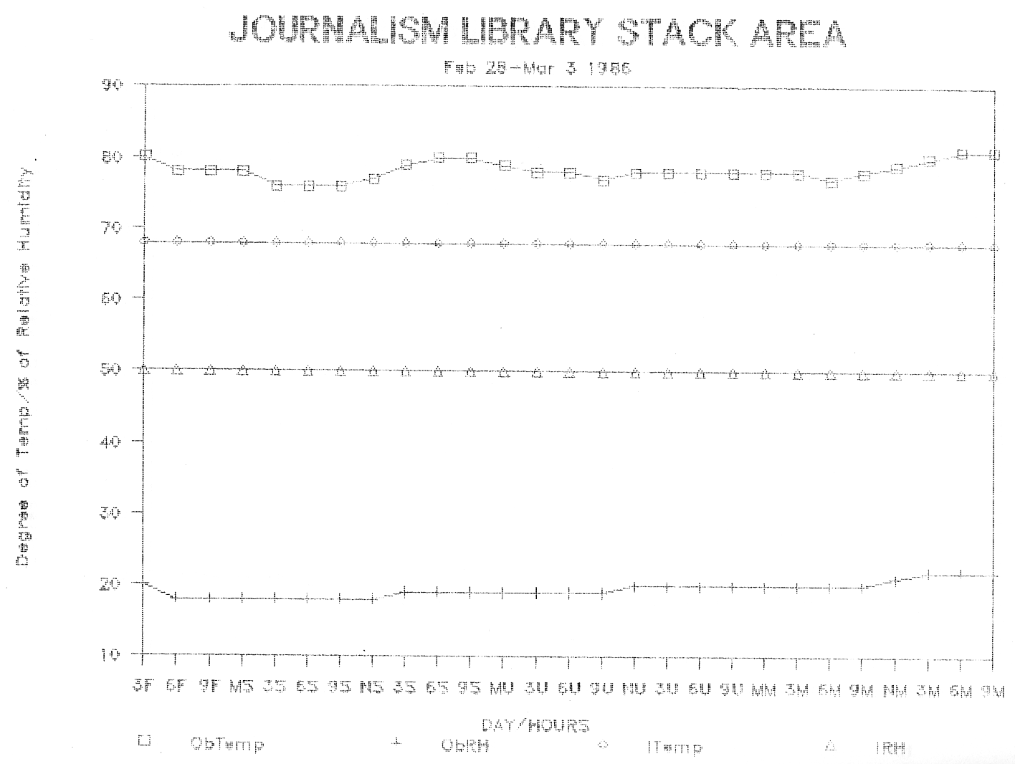

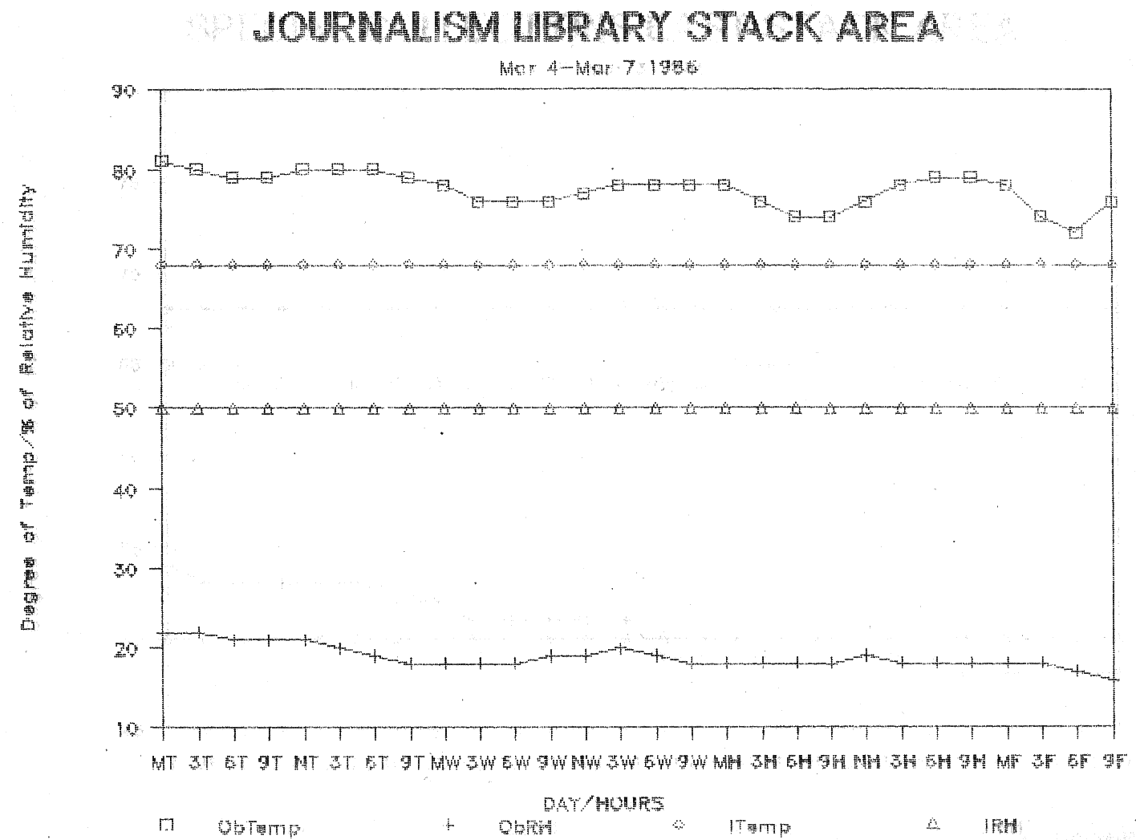

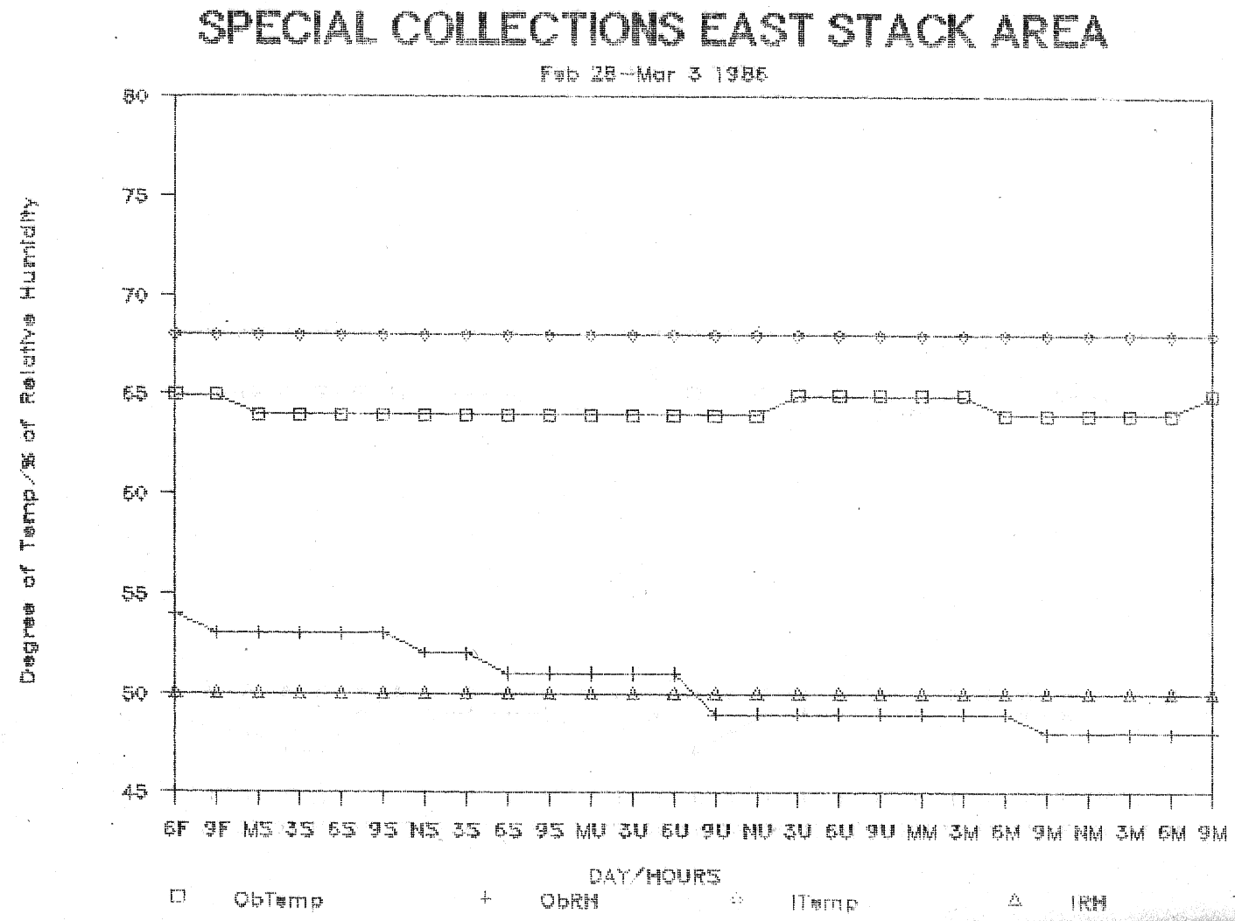

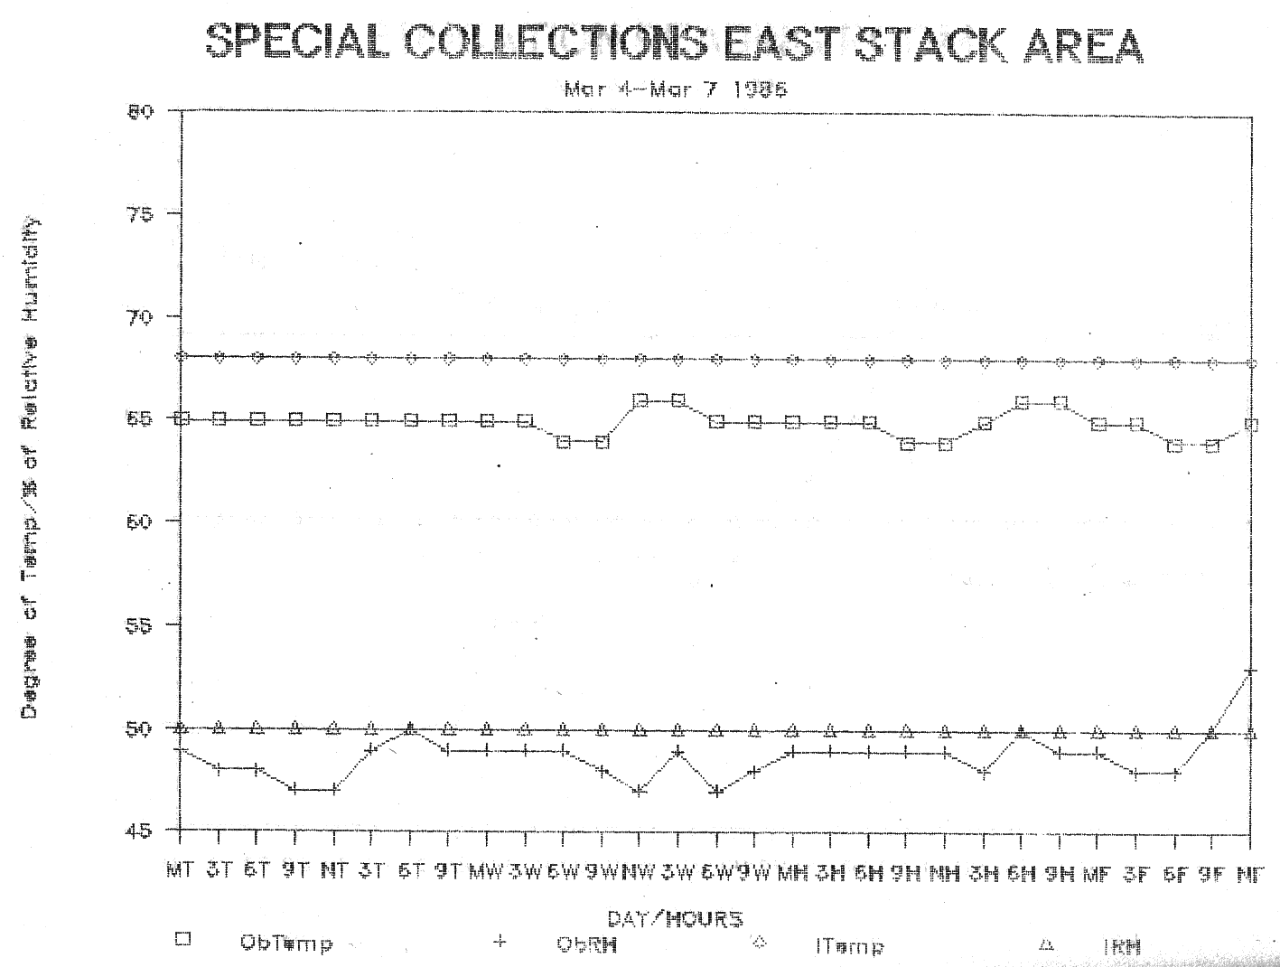

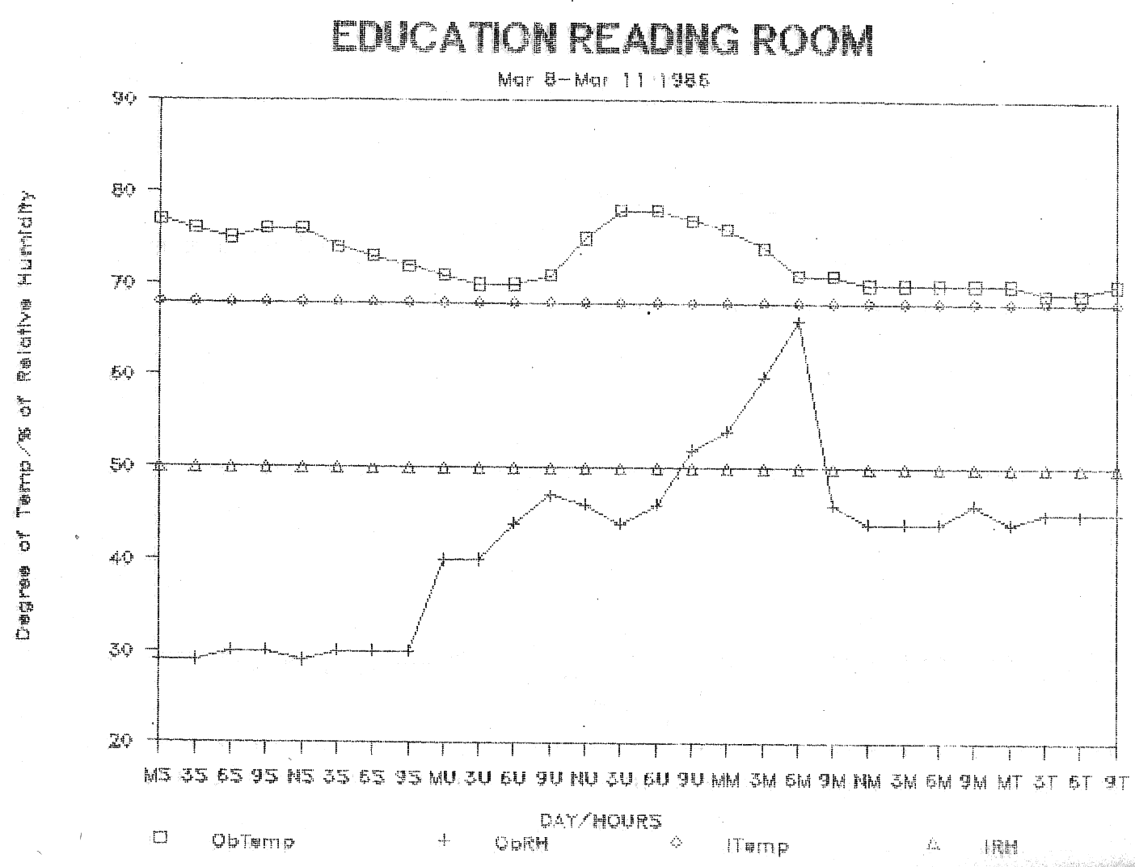

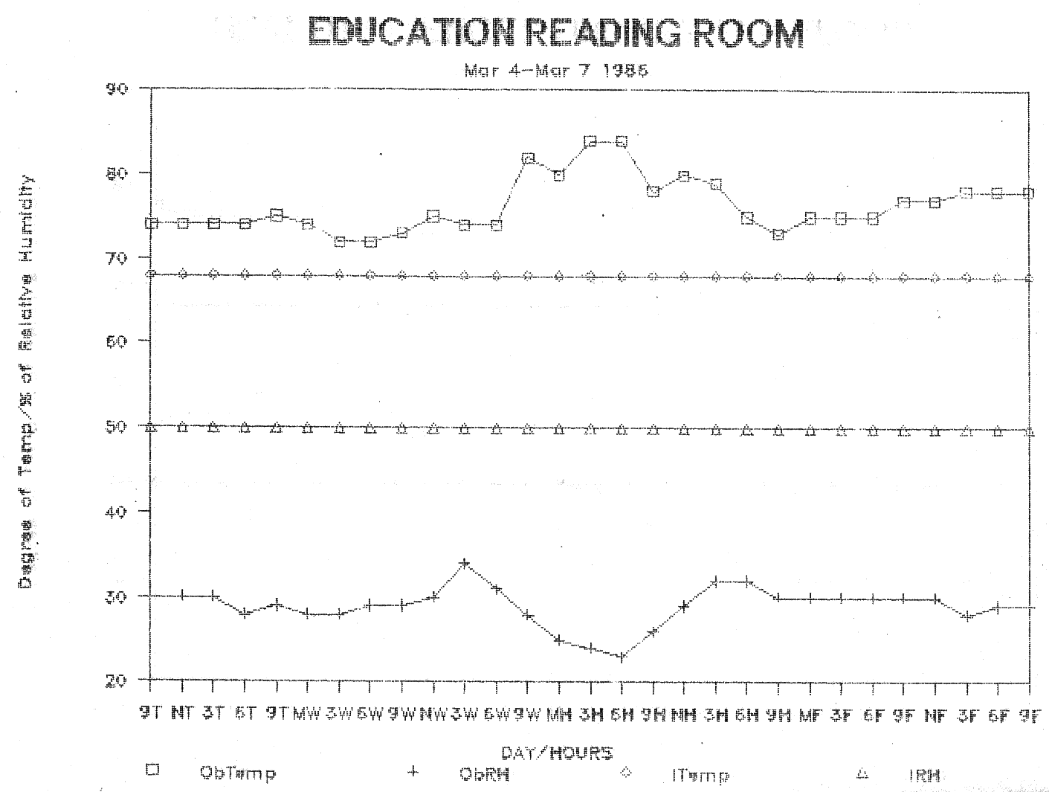

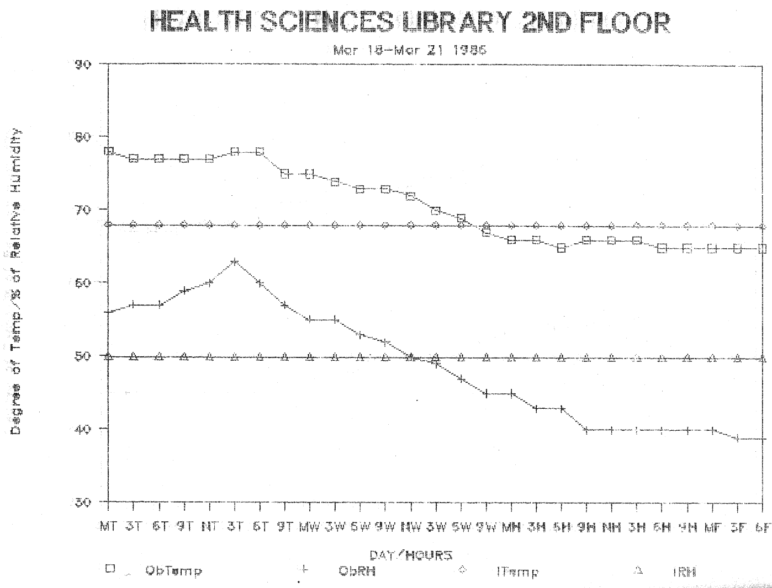

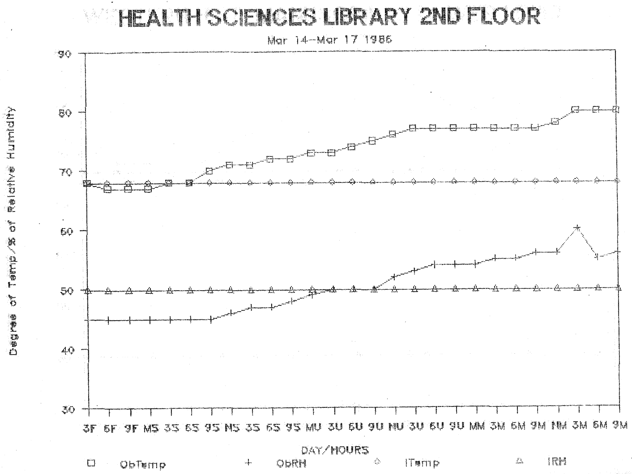

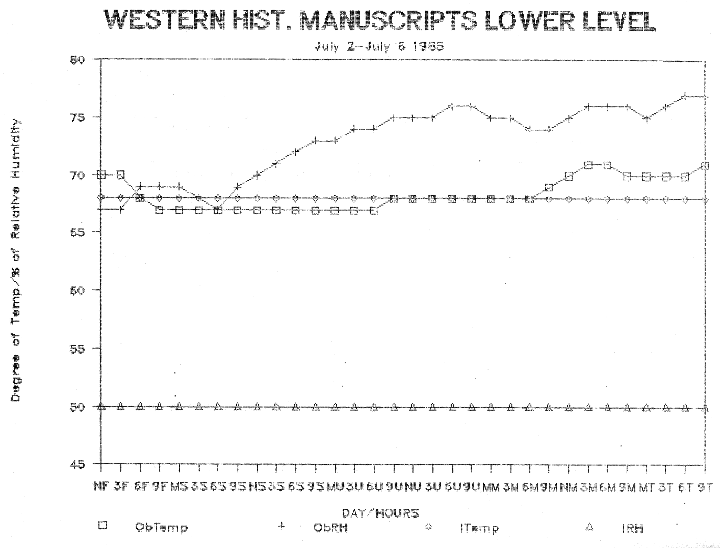

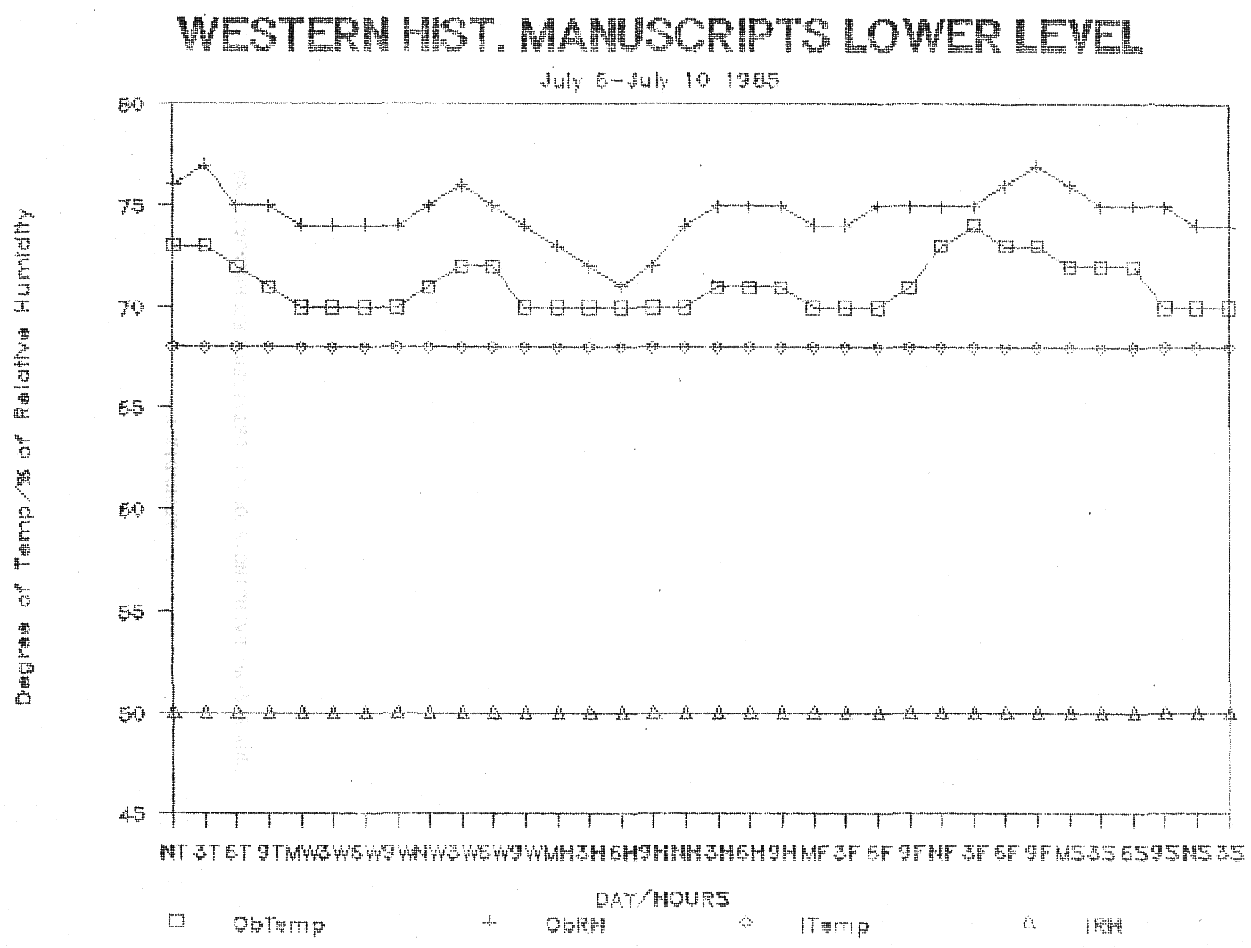

APPENDIX 2
PROCESSING/HANDLING/STORAGE DETAILED RECOMMENDATIONS
STORAGE/HANDLING/PROCESSING RECOMMENDATIONS
1.0 An ongoing program to identify materials with physical problems should be developed.
1.1 The brittle book procedures previously approved in principle should now be implemented. This includes photocopying on acid-free paper, microfilming, buying a replacement, or withdrawing the item. A new service offering archival quality reprints on demand should also be investigated. Subject area librarians should be actively involved in making decisions as to the disposition of brittle books.
1.2 A policy describing what categories of materials should be mended, rebound, boxed, etc., should be written. Subject area librarians should take an active part in creating the policy and, in cases of severe damage, decide whether a volume should be mended or replaced based on the item’s intrinsic value, value to the collection as a whole, and current and projected use.
1.3 Funds should be sought to provide more restoration of valuable materials in Special Collections and the restoration of old maps in Geology. Polyester encapsulation for manuscript maps and printed maps with historical value should be used to protect these materials.
1.4 A program to identify valuable books in the general stacks needs to be established. Books that are valuable because of age have been identified and will be transferred to Special Collections if the Title II-C grant is renewed, but books that are valuable for other reasons have not yet been identified.
1.5 New mending procedures should be implemented and be phased in over a period of one year, with a new procedure introduced every eight to twelve weeks. This would minimize the amount of staff readjustment and the amount of time the supervisor would need for training and supervision. Procedures should include replacement of damaged spines with bookcloth and acid—neutral spine strips, and recasing using original cover. Acid—free pamphlet binders sewn to acid—free endpapers and to the pamphlet are recommended. Paper repair should be made with Japanese paper and starch paste or methyl cellulose. Most, if not all, of the needed supplies to implement these new procedures are on hand. Once a new procedure is initiated it will be understood that the new procedure will be used exclusively. The old procedure will be permanently discontinued even for books whose anticipated useful life is not expected to be long.
1.6 A provision for “rush” mending should be made.
1.7 Kits of preservationally sound supplies for simple mending should be prepared for designated staff members. Staff should be trained in their use.
2.0 A vigorous preventive maintenance program for the collection should be adopted.
2.1 Collection development policies should specify that the most appropriate formats and preservationally sound materials be acquired. The recently inaugurated practice of buying microforms instead of binding of materials published on newsprint should be fully implemented.
2.2 A program to identify materials needing mending which are in early stages of disrepair should be designed.
2.3 The date due slips, book pockets, punched cards, and streamers currently used in books were tested and found to be acidic. The only form tested that did not contain acid was the inventory slip. Since book pockets and bookcards will not be used with the new circulation system it is recommended that acid-free pockets and cards be purchased only if a new supply must be ordered before the circulation system is in place. Acid—free date due slips need to be acquired for daily use. Streamers used to route material to proper areas are acidic and potentially damaging to book paper. It cannot be ascertained at the time that they are placed in the book which will be in books only a short while and which may be books sent to a backlog area; therefore, it is recommended that acid—free streamers be used. The cost would be minimal since streamers are recycled on a regular basis.
2.4 Methyl cellulose, a reversible, neutral pH glue should be used for mounting date due slips (and book pockets until their use is discontinued). Wheat paste and polyvinyl acetate are recommended as appropriate for other processes requiring adhesives.
2.5 The use of rubber bands during the processing of periodicals and microfiche should be discontinued. Microfiche should not be bundled and stored with rubber bands.
2.6 Except for unusual circumstances, the use of paper clips with library material should be discontinued. Clips are known to rust when exposed to moisture in the air and can stain as well as tear pages.
2.7 Water-based ink with inorganic pigment that does not fade with light, heat, or age (such as #125 black actinic ink) should be used for ownership stamping. A variety of stamp sizes, appropriate for the material should be used.
2.8 The use of double—sided security strips should be discontinued except when the need to protect the book from being stolen outweighs the need for long-term preservation.
2.9 The practice of labeling reference and reserve books with book tape and adhesive labels should be discontinued. Safer ways to identify reserve materials should be explored.
2.10 The practice of placing the book Jacket in the book for delivery to area libraries and branches should be discontinued. Jackets could be placed in a box in the Marking Department for librarians to pick up or could be sorted by the Marking staff and mailed to librarians.
2.11 The importance of checking materials for damage when they are received needs to be stressed. Early detection of defective materials insures a better chance of receiving replacements.
2.12 All envelopes and boxes used in microform storage should be tested for acid content and a replacement program enacted for all that are not acid—free. Microfiche should be stored one fiche per envelope.
2.13 Wrappers for securing microfilm on reels are acidic; a program of replacing them using acid—free wrappers should be implemented.
2.14 Microfilm cabinets should be secured for microfilm that is stored on book shelves. Compact shelves used for microfilm storage should be covered to protect film from dust. Engineering and Veterinary Medicine each need a microfilm cabinet.
2.15 Readers and reader/printers should be cleaned at least three times per week and daily during peak usage times to remove dust and reduce the chance of damage to the microforms.
2.16 All diazo microfiche should be stored separately from silver halide microfiche.
2.17 Care should be taken that microforms--especially microfiche--being cataloged are not damaged by other materials on catalogers’ desks. Microfiche that need handling during cataloging should be protected with envelopes. If extensive handling is necessary, the use of gloves is recommended.
2.18 Preference should be given to purchasing silver halide microforms since it is the only film medium for which there are standards for stability. When a choice of micropublishers is available, those with a record for high—quality products should be patronized.
2.19 The library should attempt to exert influence on government contractors to produce microfiche according to accepted practices. For example, if diazo film must be used, long-lived film such as Xidex DEH (19.6 hours to fade vs. others that fade in 3.4 hours) should be used.
2.20 Microfilm should be repaired with heat welds.
2.21 The purchase of more photocopiers suitable for safe book copying is recommended.
2.22 Self—service copiers should be located in areas which permit staff members to observe copying practices.
2.23 Copiers should be made available to the Math and Geology libraries for in—house copying so that material being copied need not be removed from the Library, and the photocopying practices of users may be monitored. Some other branch copiers in poor condition need to be replaced.
2.24 A policy that outlines in detail what and how materials will be bound should be adopted. The authority for compliance with the policy should be vested in one person to be named by the Head of the Serials Department, who is responsible for binding.
2.25 Insistence on high quality bindery products should continue and the level of funding should be such that all material worthy of binding can be bound. The present binding fund allocation should be increased to accommodate larger quotas for Documents, Geology, and Geography/History/Philosophy to support the additional demands placed on the bindery because of the special one-time purchases of materials during fiscal 1985/86, and to support the new regional government documents depository status of the library. The staff should be increased accordingly.
2.26 Prior to being sent to the Shelving Department, bindery slips should be removed by Marking personnel.
2.27 String should be used instead of rubber bands in bindery preparation.
2.28 The program to replace tapes and records with compact discs should continue since they are of high quality, are easier to store, and are more durable.
2.29 Wooden map cases should be replaced and additional steel map cases should be purchased.
2.30 Book trucks that are unstable, prone to damage, or subject to tipping should be replaced. New book trucks are especially needed in all branches except the Health Sciences Library and, perhaps, in the Acquisitions Department.
2.31 The distance that serials are transported for processing should be decreased to reduce the chance of damage. A better designed book truck for use with unbound periodicals would also help minimize the possibility of damage.
2.32 Fore—edge shelving of books should be discontinued. If space limitations make upright shelving of all volumes impossible at this time, an alternative, temporary method should be used.
Volumes too large for their designated shelf should be shelved on their spines, and acid—free call number streamers should be used so that the call number will be visible to shelvers and patrons. More oversize shelving should be added and a uniform volume height should be established for books designated “L”.
2.33 Shelves in all branches except Health Sciences and Veterinary Medicine need to be examined for possible replacement. New shelving in Engineering presumably will be provided in their new quarters. A variety of bookend types that include wire, base secured, and standard bookends in different sizes should be available.
2.34 Additional shelving should be provided for reserve materials in the branches and for Closed Shelf in Ellis.
2.35 Problems in the Current Periodicals Reading Room can be alleviated by implementing various recommendations. These include providing more space for storage of materials (including high—risk, sensitive items), increasing the number of staff for improved control of collections, and acquiring additional copiers that can photocopy materials with narrow inside margins.
2.36 Circulation staff should investigate acquiring no—cost plastic bags to give patrons for use of materials in inclement weather. These could be provided by vendors, book stores, or by the commercial library binder.
2.37 Frequent emptying of book drops should continue. The Circulation Department in Ellis and the branch libraries should consider locking unattended book drops during library hours. Book drops that are below standard should be replaced.
2.38 The Library Systems Office has been asked to purchase bar codes for the new circulation system that are as preservationally sound as possible. The importance of this needs to be conveyed to LSO each time specifications are written and bids are let.
2.39 The receiving room in the new addition should be provided with an adequate loading dock so that boxes of library materials can be safely moved from mail trucks to book trucks.
2.40 Library material intended for delivery within Ellis or to a branch should be tied with string or packaged in mailing envelopes or boxes. Streamers should be laid in the gutter of the book, not paper clipped to the pages. If added assurance that streamer does not fall out is needed, book can be tied with string while it is being transported. Rubber bands should not be used.
2.41 Better wrapping of library materials is recommended. Boxes received with incoming mail might be reused. If the library continues to use jiffy bags, a higher quality bag (one book per bag) would go a long way to protect the collection. Library material lent should receive
as good, or better, treatment as material borrowed.
2.42 The Library should maintain a supply of record storage boxes to be used for branch deliveries. Material that may slide or shift within the box should be supported with crumpled paper or other packing material.
2.43 Special permission to park library delivery vans close to the entrances to the building housing the branch libraries should be secured from Campus Police and/or Parking Operations so that branch deliveries need not be carried long distances unprotected from the weather.
2.44 A program of retrospective security stripping of branch books should be started.
2.45 Area and branch librarians should make a concerted effort to see that BATAB slips and other processing forms are removed from new materials before they are shelved.
2.46 A regular cleaning program should be instituted for all libraries. Rare books should be vacuumed and/or dusted using safe cleaning products.
2.47 A secure space for rare books and other vulnerable material should be provided in the new cataloging area.
2.48 A better receptacle than the current modified trash can should be provided for gift books deposited by library users.
2.49 If exhibits are to be a part of the function of the Special Collections Department, additional staff should be provided to construct safe book supports and provide safe mounts for library material displayed in the exhibits.
2.50 A formal exhibit policy should be adopted.
2.51 The staff should be more aware of sound attitudes which would be constantly and consistently applied in the preparation of exhibits. The primary purpose of exhibits is to promote library and campus resources. Exhibits can also provide a showcase for the promotion of correct preservation practices and attitudes.
3.0 The Libraries should have an ongoing program of reviewing practices, policies and supplies for their preservation soundness.
3.1 What effect the 3M tattle tape security strips have on the long term life of the volumes to which they are attached from a preservation standpoint has not yet been determined. The adhesive may be potentially damaging to book spines as well as to pages as is the case when a double-sided strip is used.
3.2 Practices with respect to the stamping, pasting, and labeling of
closed shelf material need to be studied.
3.3 The possible use of preservationally sound ink such as #125 black actinic ink for use in Bates numbering machines should be investigated.
3.4 The ongoing discussions among preservation professionals concerning the desirability of treating leather bindings with potassium lactate, and neat’s—foot oil and lanolin should be monitored.
3.5 Ongoing literature reviews need to be performed regarding the proper way to clean microforms, how to straighten curled microfiche and microcards, and the effects of light and heat from copiers including fiche-to—fiche duplication and reader/printers on microforms.
3.6 The purchase of the nondestructive book copier developed by Morgan Data Conversion, Inc. should be considered.
3.7 The microfilm collection needs to be surveyed for brittleness and scratching to see if a replacement program needs to be started.
3.8 The long term effect of the green ink on the edges of the journals in the Current Periodical Reading Room as a security device should be studied.

