To get to the MERLIN Catalog, start at the MU Libraries’ Gateway: http://mulibraries.missouri.edu.  Then, you can go in one of two ways:  - “I need to…” Sidebar  - “Books and More” Tab | 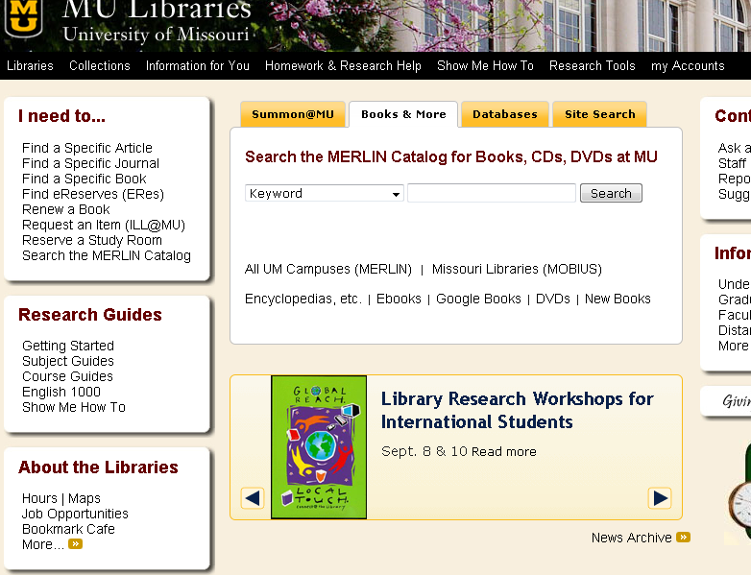
Keyword, Author, & Title Searches can be selected in this dropdown menu. | 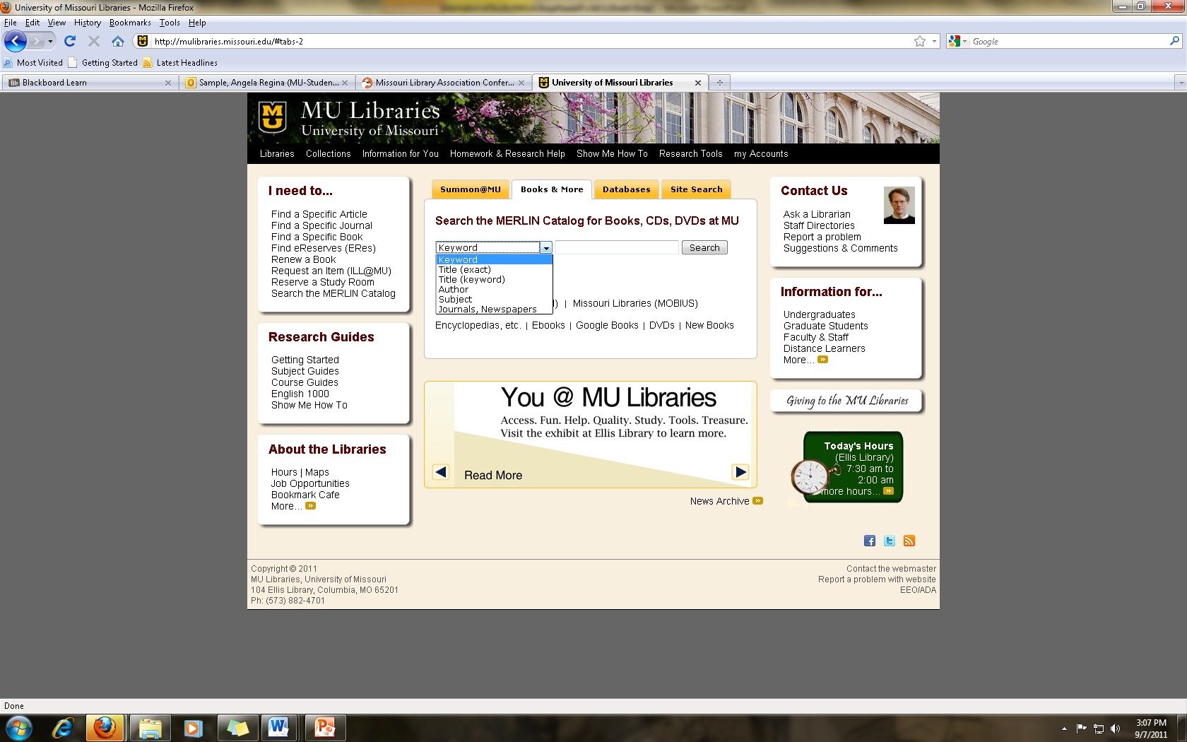
An example MERLIN record
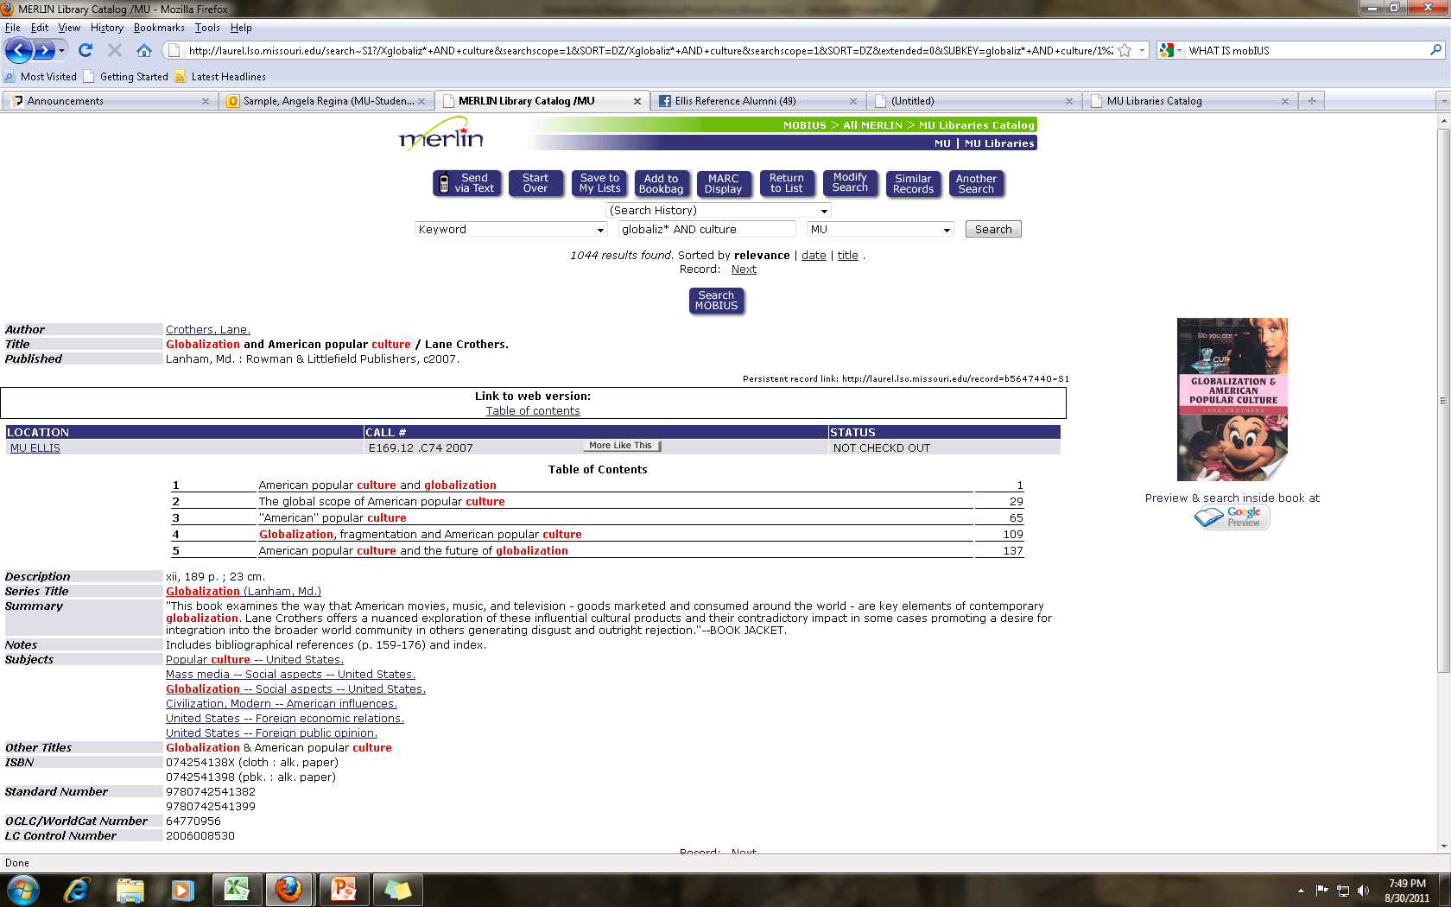

Title, author, and publication information

Remember to check the Location, Call Number, and Status.
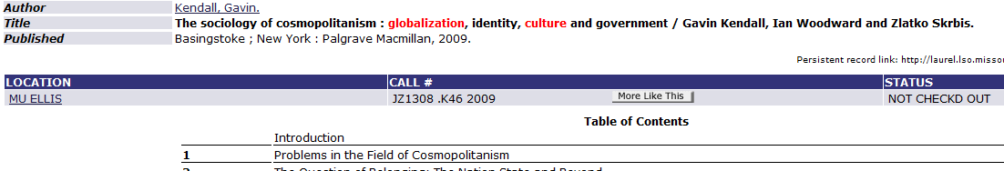
You can also search ALL MERLIN by selecting from this dropdown menu. | 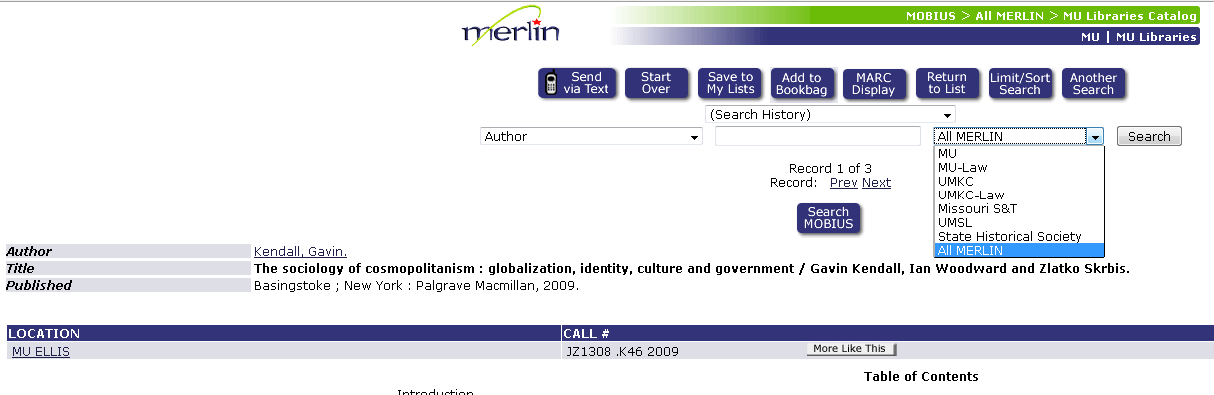
You can also search MOBIUS. The best way to get there is by clicking on this button.
Refer to your PowerPoint handout for more information on other topics including more details about MERLIN, requesting items from MOBIUS, and ILL@MU.

